DOKUMENTASI EMPLOYEE & ORGANIZATION UNIT

Requirement:
- ip client didaftarkan terlebih dahulu ke system jasmine untuk digenerate tokennya

method = GET
header = {‘token’: jdkdkdkx}

- Master level organization unit
relative url: /api/unit/level

contoh response:
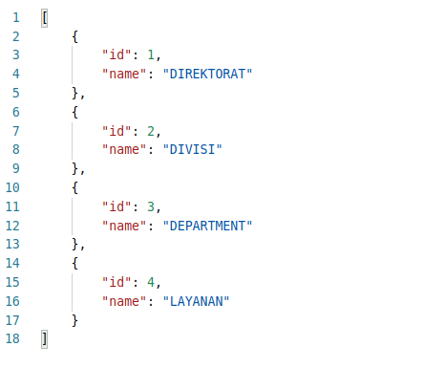
- Daftar organization unit by level
relative url: /api/unit/by_level/<level_id>

contoh:
Daftar semua department, maka level_idnya adalah 3
url: /api/unit/by_level/3
response:
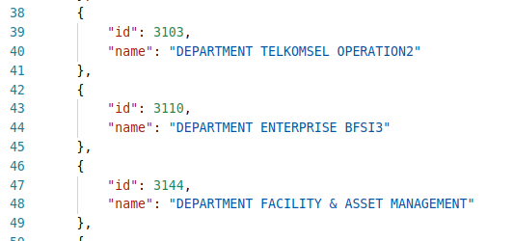

- Daftar org unit by parent
relative url: /api/unit/by_parent/<parent_id>

contoh:
Daftar semua layanan yg ada dibawah department Telkomsel Operation2, maka parent_id 3103
url: /api/unit/by_parent/3103
response:
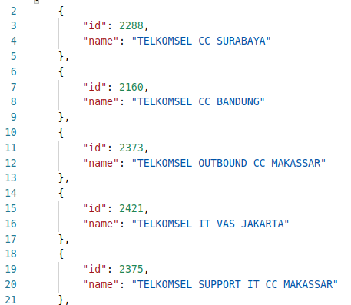

4. Daftar Employee by Org Unit
relative url: /api/employee/by_unit/<unit_id>

contoh:
Daftar semua employee yg ada di layanan, unit_id: 2288
url: /api/employee/by_unit/2288
response:
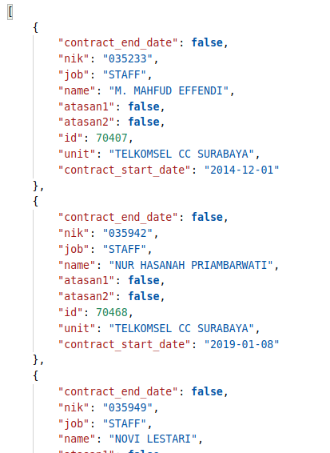
5. Data Employee by id
relative url: /api/employee/data/by_id/<employee_id>

contoh:
Data detail dari employee Nur Hasanah Priambarwati, id: 70468
url: /api/employee/data/by_id/70468
response:
