Supplementary
Measurement And Structural Model Assessment

The performance of the village government from a society/community perspective (Hoque & Adams, 2011) originally has eight indicators (socper1-socper8). The final algorithm produces three indicators left with outer loading above 0.700 (Hulland, 1999). This latent variable (construct) has high indicator reliability (above 0.700) and satisfied average variance extracted (above 0.500). Therefore, this construct achieves the validity requirements (Bagozzi & Yi, 1988; Jörg Henseler, 2010). The second latent variable is the diffusion of IS innovation. This variable has seven indicators, and the final algorithm deletes one item due to its low loading factor (below 0.70). as shown in table 3, all outer loading for this variable with six indicators is higher than 0.700. Hence, indicator reliability results employing Cronbach alpha and composite reliability also achieve the requirement. Hence, the average variance extracted (AVE) indicate a value above 0.500. therefore, this latent variable satisfied the convergent validity provision.
Table 1. Convergent validity
variable | item | outer loading | Cronbach's Alpha | Composite Reliability | Average Variance Extracted (AVE)
moderating 1 | disi * ors | 1.462 | 1.000 | 1.000 | 1.000
moderating 2 | disi * tag | 1.660 | 1.000 | 1.000 | 1.000
diffusion of IS innovation | disi2 | 0.750 | 0.916 | 0.933 | 0.701
diffusion of IS innovation | disi3 | 0.848 | 0.916 | 0.933 | 0.701
diffusion of IS innovation | disi4 | 0.810 | 0.916 | 0.933 | 0.701
diffusion of IS innovation | disi5 | 0.887 | 0.916 | 0.933 | 0.701
diffusion of IS innovation | disi6 | 0.873 | 0.916 | 0.933 | 0.701
diffusion of IS innovation | disi7 | 0.848 | 0.916 | 0.933 | 0.701
organization support | ors1 | 0.921 | 0.870 | 0.917 | 0.787
organization support | ors2 | 0.933 | 0.870 | 0.917 | 0.787
organization support | ors3 | 0.803 | 0.870 | 0.917 | 0.787
society perspective performance | socper1 | 0.897 | 0.889 | 0.931 | 0.818
society perspective performance | socper2 | 0.911 | 0.889 | 0.931 | 0.818
society perspective performance | socper3 | 0.905 | 0.889 | 0.931 | 0.818
technology advantage | tad1 | 0.930 | 0.930 | 0.955 | 0.877
technology advantage | tad2 | 0.937 | 0.930 | 0.955 | 0.877
technology advantage | tad3 | 0.943 | 0.930 | 0.955 | 0.877

The third latent variable in this study is organisational support. This construct has three indicators, and all indicator has outer loading above 0.700. in addition, the indicator reliability using Cronbach alpha and composite reliability shows that the variable satisfied the indicator reliability requirement (above 0.700). Hence, the average variance extracted (AVE) achieves the standard (above 0.50). Therefore, we can conclude that this latent variable satisfies the convergent validity requisite. The last latent variable is technology advantage. This construct has three indicators, and the algorithms produce all valid indicators due to their outer loading above 0.700. Based on the argumentation above, we can conclude that all latent variables and their hand has a necessary convergent validity.

Table 2. Fornell-Lacker criterion
variable | mod1 | mod2 | DISI | ORS | SOCPER | TAG
Moderating Effect 1 | 1.000
Moderating Effect 2 | 0.664 | 1.000
diffusion of IS innovation | -0.302 | -0.303 | 0.837
organization support | -0.281 | -0.233 | 0.561 | 0.887
society perspective performance | -0.048 | -0.040 | 0.324 | 0.311 | 0.905
technology advantage | -0.264 | -0.408 | 0.650 | 0.651 | 0.392 | 0.937

The second validity assessment for the measurement model is discriminant validity. There are three types of this assessment. The first type is the Fornell-Lacker criterion (Fornell & Larcker, 1981), and the result of this validity test is shown in table 3. The bold number should be greater than the number below and left side. The square root of the construct’s AVE creates the bold number. İn addition, another number is the correlation between the particular construct and other constructs. For example, 0.837 is a square root of DISI’s AVE, and 0.561 is a coefficient correlation of DISI with ORS. All latent variables achieve the necessary discriminant validity based on the Fornell-Lacker criterion.

Table 3. Cross loading
item/variable | mod1 | mod2 | DISI | ORS | SOCPER | TAG
Moderating Effect 1 | 1.000 | 0.664 | -0.302 | -0.281 | -0.048 | -0.264
Moderating Effect 2 | 0.664 | 1.000 | -0.303 | -0.233 | -0.040 | -0.408
disi2 | -0.173 | -0.293 | 0.750 | 0.329 | 0.168 | 0.503
disi3 | -0.249 | -0.317 | 0.848 | 0.484 | 0.273 | 0.605
disi4 | -0.279 | -0.304 | 0.810 | 0.573 | 0.225 | 0.625
disi5 | -0.284 | -0.214 | 0.887 | 0.474 | 0.395 | 0.540
disi6 | -0.224 | -0.210 | 0.873 | 0.460 | 0.252 | 0.501
disi7 | -0.289 | -0.233 | 0.848 | 0.493 | 0.212 | 0.512
ors1 | -0.279 | -0.169 | 0.520 | 0.921 | 0.308 | 0.594
ors2 | -0.265 | -0.270 | 0.546 | 0.933 | 0.315 | 0.658
ors3 | -0.180 | -0.169 | 0.398 | 0.803 | 0.157 | 0.430
socper1 | -0.018 | -0.011 | 0.336 | 0.309 | 0.897 | 0.339
socper2 | -0.066 | -0.066 | 0.307 | 0.234 | 0.911 | 0.389
socper3 | -0.047 | -0.031 | 0.230 | 0.305 | 0.905 | 0.332
tad1 | -0.253 | -0.398 | 0.610 | 0.596 | 0.347 | 0.930
tad2 | -0.263 | -0.391 | 0.612 | 0.653 | 0.388 | 0.937
tad3 | -0.227 | -0.357 | 0.604 | 0.576 | 0.363 | 0.943

The second assessment for discriminant validity is cross-loading. This analysis aims to avoid an indicator loading to more than one construct. İf any indicator loads to more than one construct, the discriminant validity does not achieve. The cross-loading result is produced by running the algorithm menu in smart-pls. The result of the cross-loading can be seen in table 3. The indicator of performance, socper1-socper3, loading to the construct of society perspective performance with loading factors 0.897, 0.911, and 0.905, respectively. These loading factors are higher than their loading to technology advantage: 0.339, 0.389, and 0.332, respectively. The detail of cross-loading for each latent variable is demonstrated in table 4. The third assessment for discriminant validity is htmt. The result of htmt is shown in table 4. Based on table 6, all latent variables have a value of htmt lower than 0.85, which is cut off to decide whether it supports the discriminant validity (Kline, 1998). İn brief, the htmt support the discriminant validity.
Table 4. HTMT
variable | mod1 | mod2 | DISI | ORS | SOCPER | TAG
Moderating Effect 1
Moderating Effect 2 | 0.664
diffusion of IS innovation | 0.311 | 0.326
organization support | 0.290 | 0.244 | 0.612
society perspective performance | 0.051 | 0.042 | 0.333 | 0.333
technology advantage | 0.274 | 0.423 | 0.707 | 0.698 | 0.429

The measurement model assessment is completed, and the measurement model can be seen in figure 2 below. The second assessment in smart-pls is structural model assessment. This assessment is to test the hypothesis. However, we need to gain information about the predictive relevance of the model since this study is to develop the model based on the resources-based theory and technology organization environment (TOE). The blindfolding menu produces the predictive power (Q square). The above Q square indicates that the exogenous variable has a predictive relevance to the endogenous variable under consideration. The result shows that the value of the Q square is 0.141 (see Figure 3) and is categorised as medium predictive relevance (Jorg Henseler et al., 2009).

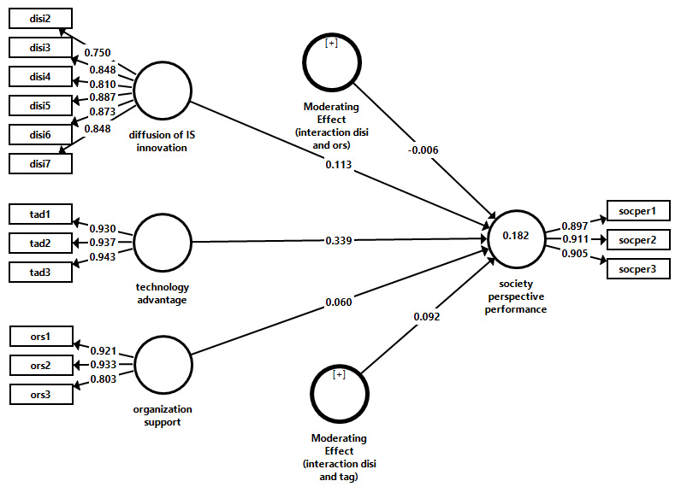 | 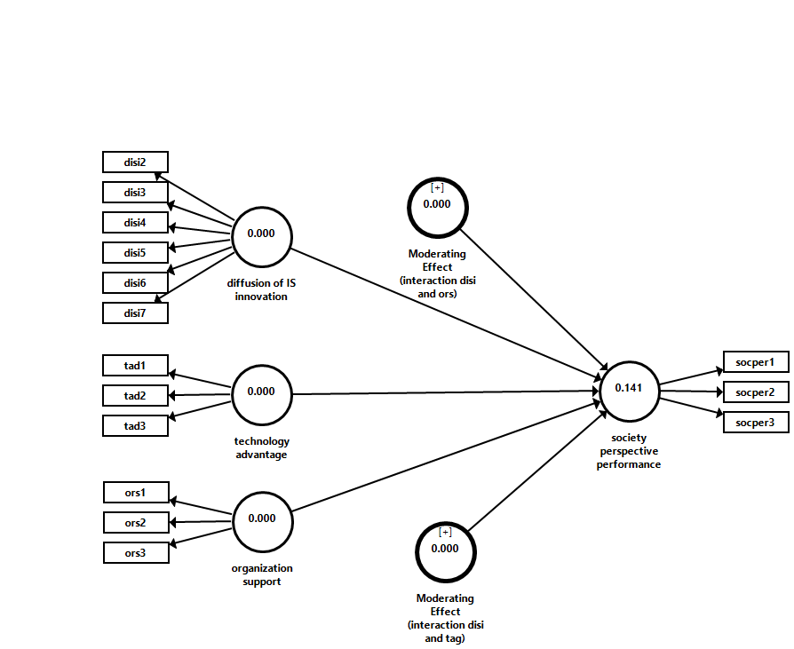
Figure 2. measurement model | Figure 3. blindfolding result (Q square)

The measurement model assessment is completed, and the measurement model can be seen in figure 2 below. The second assessment in smart-pls is structural model assessment. This assessment is to test the hypothesis. However, we need to gain information about the predictive relevance of the model since this study is to develop the model based on the resources-based theory and technology organization environment (TOE). The blindfolding menu produces the predictive power (Q square). The above Q square indicates that the exogenous variable has a predictive relevance to the endogenous variable under consideration. The result shows that the value of the Q square is 0.141 (see Figure 3) and is categorised as medium predictive relevance (Jorg Henseler et al., 2009). The second structural model assessment is predictive power. PLS-SEM aims to maximise the R square of endogenous variables in the path model (Hair et al., 2017). Figure 2 indicates this model's value of R square (0.182). In addition, 0.182 is grouped into moderate (Cohen, 1992). Therefore, the variation in an endogenous variable can be explained by 18.2% of the exogenous variables.

