DOES IS INNOVATION DIFFUSION CONTRIBUTE TO NON-FINANCIAL PERFORMANCE OF VILLAGE GOVERNMENT?

Zaitul¹  ¹Faculty of Economics and Business,  Universitas Bung Hatta, Indonesia  zaitul@bunghatta.ac.id |  | Desi Ilona²  ²Faculty of Economics and Business, Universitas Putra Indonesia YPTK, Indonesia  desiilona@upiyptk.ac.id
Neva Novianti³  ³Faculty of Economics and Business,  Universitas Bung Hatta, Indonesia  nevanovianti@bunghatta.ac.id |  | Eugene Okyere-Kwakye⁴  ⁴Faculty of Business and Management Studies, Koforidua Technical University, Ghana  Eokyerekwakye2@gmail.com
ABSTRAK  Pentingnya difusi inovasi SI dalam menentukan kinerja suatu organisasi telah didokumentasikan oleh penelitian sebelumnya. Namun, penelitian sebelumnya pada topik ini sangat terbatas menggunakan organisasi publik sebagai objek penelitian, seperti pemerintah desa. Penelitian ini bertujuan untuk mengetahui peran resouces based view dan technology organization environment dalam menjelaskan variasi kinerja pemerintah desa. Secara khusus, penelitian ini menganalisis pengaruh difusi inovasi SI terhadap kinerja pemerintah desa. Selain itu, penelitian ini juga menentukan peran dukungan organisasi dan keunggulan teknologi dalam menentukan kinerja. Terakhir, penelitian ini juga meneliti variabel-variabel tersebut sebagai variabel pemoderasi antara difusi inovasi SI dan kinerja. Data primer dikumpulkan melalui survei dan dianalisis menggunakan smart-pls. Hasil penelitian menunjukkan bahwa satu hipotesis mendukung bahwa keunggulan teknologi berhubungan secara signifikan dengan kinerja pemerintah desa. Temuan ini secara teoritis berkontribusi pada technology organization environment. Secara praktis, temuan ini dapat diterapkan oleh pemerintah desa untuk meningkatkan kinerja dari perspektif TOE ini. |  |  |   ASSETS  Jurnal Akuntansi  dan Pendidikan  Vol. 6 No. 1  Hlmn. 85-92  Madiun, Oktober 2017  p-ISSN: 2302-6251  e-ISSN: 2477-4995  Artikel masuk:  1 Agustus 2017  Tanggal diterima:  17 Agustus 2017
Kata Kunci : | IS innovation diffusion; organization support; technology advantage; village government; Indonesia
ABSTRACT
The importance of IS innovation diffusion in determining the performance of an organization has been documented by previous research. However, a very limited previous study on this topic uses public organizations as research objects, like the village government. The aim of this study is to know whether the resources-based view and technology organization environment in explaining variation in village government performance. Specifically, this research paper analyzes the influence of IS innovation diffusion on the performance/ outcome of the village government. Besides, this paper also determines the role of organisational support and technology advantage in determining performance. Finally, this study also researched these variables as moderating variables between IS innovation diffusion and performance. The primary data was collected through a survey and analysed using the smart-pls. The result shows that one hypothesis supported that the technology advantage is significantly associated with the performance of the village government. This finding theoretically contributes to the technology organization environment. Practically, this finding can be applied by the village government to improve the performance from the TOE perspective.

Keywords : | IS innovation diffusion; organization support; technology advantage; village government; Indonesia
JEL Classification: | M410  O330

INTRODUCTION

The e-government era has been accompanied by many transformations to public sector organisation administration (Zavattaro & Brainard, 2019). Public sector organizations have started adopting the digital government strategy to integrate with their customer and partner institutions. The IS has become a crucial part of the toolkit for public administrators, given the capability to integrate with their suppliers and customers (Mergel, 2013). Due to the rising utilization of technology in the government and the interplay between government and citizens via the website’s government motivate alteration in the bureaucracy of internal government (Roengtam et al., 2017). İn this condition, the governments have to reconsider their designs of social medium and shift the rising demand for entrance to unfasten data and user involvement into a new structure that authorises society empowerment (Hossain et al., 2018). Web-based technology has two functions: internal and external. Internally, the application of the web and other communication and information technologies has become an efficient and effective managerial tool to gather, save, arrange and govern information and data (Adiputra et al., 2018). Externally, technology which is based on web can ease public connection within the society.
Swanson and Ramiller (2004) argue that IS innovation refers to the invention of digital and communications technology and its application. There are several benefits to why IS innovations need to be done in an organization. Moghavvemi et al. (2012) state that IS innovation generates changes by making better its level of effectiveness or performance. İn addition, other experts inform that the information system is a source of the competitive advantage of an organization (Bharadwaj, 2000). Hence, IS innovation can create valuable resources and link to an organisation's performance. Innovations diffusion refers to the procedures through which new technology is embraced by many actors throughout the community – important for social, economic, and ecologically sustainable development (Palm, 2022). Experts have provided designs in particular dealing with innovation in information systems (Rogers, 1995). These designs were frequently directed as phase-based operations, such as the three phases of initiation, adoption, and implementation (Grover & Goslar, 1993). This diffusion procedure and the process is complex and dynamic; inspecting these procedures entails understanding the basic evolutionary shift across time ( Wu & Chuang, 2010).
The previous research investigating the association between performance and IS innovation diffusion has been done largely (Ranganathan et al., 2004; Tanriverdi, 2005; Wu & Chuang, 2010; L. Wu & Chen, 2014; Zaitul et al., 2022). Ranganathan et al. (2004) investigate the diffusion of web technology for supply chain management (SCM) and performance. Tanriverdi (2005) research the effect of e-knowledge management and performance of fortune 1000 companies. İn addition, Wu and Chuang (2010) determine the impact of e-supply chain management diffusion and performance. Hence, Wu and Chen, (2014) researched the IS innovation diffusion and performance. They also test the TOE variables as moderating variables. Therefore, Zaitul et al. (2022) found that the diffusion of IS innovation in the village (village-based tourism) government has a positive association with the internal process performance. Thus, they also conclude that technology advantage plays a full moderator between the diffusion and performance of the village-based tourism government. Future investigation is suggested to add another TOE variable as moderating variable and test using other village governments (not only village-based tourism (Zaitul et al., 2022). Further, the role of technology organization environment (TOE) variables: organization support and technology advantage as moderating variable between IS innovation diffusion and performance also have been conducted (Elbanna & Newman, 2022; García-Sánchez et al., 2018; Hsu et al., 2018; Wu & Chen, 2014). García-Sánchez et al. (2018) Study the assignment of support of top management (organization support) as independent and moderating variables on performance measured by reverse logistics. İn addition, (Hsu et al., 2018) investigate whether the organization's support contributes to service innovation and analyse its moderating role. Finally, Elbanna and Newman (2022) also examine the effect of organisational support on digital transformation and performance.
Based on the prior research, studies on IS innovation diffusion and performance and the role of the TOE variables have been done using the private sector or companies. A very limited of previous studies applied to the public sector, especially the village government. The village government is Indonesia's lowest-tier government type (Antlöv et al., 2016). The IS innovation diffusion is working in this kind of organization. Therefore, it needs to study the effect of this diffusion on performance. This study aims to confirm the resources-based theory since the IS innovation diffusion produces the IS asset and IS capability (Santhanam & Hartono, 2003; Wade & Hulland, 2004). Assets are intangible or tangible resources employed in the procedures to generate, make, or deliver products/services to a community or marketplace. In addition, capabilities are related to repeatable activities in utilizing assets to design, manufacture, or provide services or products to a community (Grant, 1991; Wade & Hulland, 2004). İn addition, another objective of the study is to confirm whether the TOE framework can explain this phenomenon. Specifically, this research paper analyzes the influence of IS innovation diffusion on the performance/ achievement of the village government. Besides, this study also determines the role of organisational support and technology advantage in determining performance. Finally, this study also researched these two variables as moderating variables between IS innovation diffusion and performace. This paper is oranised as follow: Introduction, Method, Result and Discussion, and Conclusion and Recommendation. Before proceeding to the method of this study, we review the relevance literature: performance, IS innovation diffusion, technology advantage, and organization support. Beside, we also develop five hypotheses.
Performance is the outcome of the strategy implementation through resources used by an organization. Traditionally, the profit-oriented organization has employed financial performance. Even though the financial performance has several limitations, such as short-term and shareholder orientation, they were massively used. İn addition, in a conventional performance or achievement evaluation system, indicators of the last financial performance in a given period are announced rather than how the management can increase performance (Y. Lee & Moon, 2008). the non-financial performance gave managers or executives an extra “balanced” perspective of the performance of an organization (Kaplan & Norton, 1992). Hence, the conventional financial indicator or measures from accounting information systems, such as ROA and ROI, provide a limited and insufficient portrait of the organization or company's performance, and a dependency on such indicators prevents the generation of the value of the future business (Wu & Chen, 2014). There are five issues regarding the financial measure(Kaplan & Norton, 1992): (i) financial measure leads to conflict among divisions, (ii) managers may feel encouraged to maximise the accounting profit at the expense of the long time value, (iii) and business unit may be not comparable. Therefore, the organization needs to have non-financial performance. (Frost, 2019) argues that non-financial performance could be from the view of learning and growth, internal process, customer, and society. İn this study, we use performance from a societal perspective. İn addition, it relates to the service attributes, customer or society relationships and organization reputation. The performance/ achievement of the village administration is the product of the IS innovation diffusion, technology advantages and organization support. Therefore, the theory of resource-based (Barney, 1991) and technology organization environment (Tornatzky & Fleischer, 1990) are used to underpin these relationships.
The theory of innovation diffusion (IDT) underpins innovation diffusion. İt refers to the procedures by means of innovation conveyed across specific lines from time to time among the social system members (Rogers, 2003). The diffusion procedures or process is dynamic and complex, incriminates an expanding concept over time, and needs a multi-phase investigation to supply insight into the difficulties of executing IS innovation and how they can be resolved in an organization (Wu & Chen, 2014). The experts have identified the multi stages for innovation diffusion, such as two stages model: adoption, and implementation (Rogers, 2003), three stages model (Grover & Goslar, 1993), and four stages model (Swanson & Ramiller, 2004), five stages model (Meyer & Goes, 1988), and six stages model (Rajagopal, 2002). Many experts have defined the word innovation. For example, Rogers (1995) describes innovation as the premier or prematurely use of a plan or idea by one of a set of organisations with the same goals. The IS innovation refers to the communications and digital technology innovation and its application (Swanson & Ramiller, 2004). IT innovation in an organization generates changes by increasing its level of effectiveness or performance (Moghavvemi et al., 2012). Bharadwaj (2000) argue that the information system is a source of an organization’s competitive advantage. Wu and Chen (2014) conclude that IS innovation is positioned to produce a unique and worthwhile resource connecting to firm performance. Previous studies using the village government as a research object were none. However, previous studies employing the economics institution as a research object has been done (Palm, 2022; Ranganathan et al., 2004; Tanriverdi, 2005; I. Wu & Chuang, 2010; I. L. Wu & Chen, 2014). İn addition, the most recent study using public sector institution found that diffusion of IS innovation has a positive impact on performance of the village-based tourism government. Therefore, we posit the hypothesis for village government as follows.
H1: The diffusion of IS innovation is related to the performance of the village government.
The diffusion of IS innovation in an organization needs to consider the technology organization environment or TOE framework/model to result in implementation success (Premkumar & Roberts, 1999). This model identified one of its variables: technology advantage. Technology advantage is from the word of technology in TOE. Wang et al. (2010) proposed the technology characteristics (compatibility, complexity relative, and advantage) as determinants of radio frequency identification diffusion (RFID). The degree to which an innovation is viewed as supplying greater organizational welfare than the idea it replaces or the status quo is the definition of relative advantage (Rogers, 1995). İn addition, it is sensible that organizations contemplate the advantages that arise from adopting innovations (Wang et al., 2010). Evaluating the advantages of the new technology is a part of rational adoption decisions in an organization (Premkumar & Roberts, 1999). İn addition, Premkumar and Roberts (1999) adds that the ICT provides several benefits to adopters: time information available for decision making, better customer service, reduced turn-around time, and reduced cost and. No previous studies investigated the relationship between technology advantage and the performance of the village government. However, several studies analyse the effect of technology advantage and performance on other objects. For example, Wu and Chen (2014) found a relationship between technology advantage and performance. İn addition, Eisend et al. (2016) investigated the marketing relative advantage over technology ability in affecting the performance of the new product and found that technology advantage is measured by relative advantage in new product performance. Hence, Erskine et al. (2019) conclude that technology advantage (using a heats map) contributes to the task's technology relevance and performance of decision-making. Finally, Japutra et al. (2022) found that the relative advantage improves customer engagement behaviour with mobile commerce applications and affects marketing performance. Therefore, the technological advantage contributes to the performance of an organization, such as the village government. İn addition, Wu and Chen (2014) also proposed that the technology advantage play moderating role between IS innovation diffusion and the organization's performance. Finally, Zaitul et al. (2022) conclude that technology advantage moderates the association between the diffusion of IS innovation and the organisational performance of the village-based tourism government. Hence, we posit two hypotheses in this section.
H2: Technology advantage is related to the performance of the village government.
H3: technology advantage moderates the relationship between IS innovation diffusion and the performance of the village government.
The second TOE variable is from an organisational aspect, such as organizational support. Organizational support through top management is crucial in adopting new technologies and has been revealed to be positive (Grover & Goslar, 1993; Premkumar & Roberts, 1999). Organizational support through the support of top management is crucially necessary for the fruitful execution of any system (Lederer & Mendelow, 1988). İt can advance support, commitment, a long-term strategic vision, and an initiative to generate constructive circumstances for innovation (Lee & Kim, 2007; Mcginnis & Ackelsberg, 1983). Hence, Grover and Goslar (1993) add that organisational support is crucial for producing a supportive atmosphere and supplying sufficient assets for implementing new technology. Previous studies about the role of organization support in IS innovation diffusion or technology adoption and the village government performance were none. İn fact, the previous studies using the private sector or company were limited. Wu and Chen (2014) conducted the same study and analysed the role of organisational support and its effect on performance. In addition, they also investigate the role of organization support as moderating variable between IS innovation diffusion and performance Wu and Chen (2014). García-Sánchez et al. (2018) found that there is a role of top management support (organization support) toward performance measured by reverse logistics. İn addition, top management support also plays a moderating variable between technological skill and reverse logistics as a proxy for performance (García-Sánchez et al., 2018). Hence, Hsu et al. (2018) also found that top management support contributes to service innovation. Then, leading management support moderates the association between technology adoption openness and service innovation (Hsu et al., 2018). Finally, digital transformation supports top management Elbanna and Newman, (2022). Based on the argumentation above, we develop the following hypotheses. The research framework is shown in Figure 1 below.
H4: organization support influences the performance of the village government.
H5: organization support moderates the relationship between IS innovation diffusion and the performance of the village government.

Figure 1. Research Framework

METHOD

This study involves forty-seven village governments in pariaman city, excluding the village-based tourism government. Four respondents from four divisions represent each village government: secretariat, general affair, planning affair dan financial affair. The primary data using questionnaires is collected through a survey. Surveyors visit the village government office, leave four questioneers and ask them to fill out. They are given one week time to finish it. A week later, the surveyor collected the questionnaires from the office—three variables were used in this study: dependent, independent, and moderating. Society perspective performance is the dependent variable of this study. This variable is measured by eight indicators (items) developed by experts and previous studies (Ellingson & Wambsganss, 2001; Hoque & James, 2000; Maiga & Jacobs, 2003; Solano et al., 2013; Yeniyurt, 2003). The independent variable is the diffusion of IS innovation. There are two dimensions for these variables: (i) the extent to which the users’ behaviours across various IS innovations and (ii) various diffusion stages (Fichman, 2001) with seven items. Finally, moderating variables are technology advantage (three items) and organization support (three items) which were adopted from previous studies (Premkumar & Roberts, 1999; Wang et al., 2010). The detail of the measurement of variables is shown in table 1 below. Five Likert scales are used to respond to respondents: starting from very disagree (1) to very agree (5). The data is examined by employing the structural equation model (SEM-PLS) since this study is to develop the model (Chin, 1998) of the relationship between diffusion of IS innovation and performance using the TOE and resources-based theory. İn addition, smart-pls are employed, and there are two assessments when using the smart-pls: structural model and measurement model evaluation or assessment (Hair et al., 2017).

Table 1. Measurement of Variables
Variable | Code | Item | References
Diffusion of IS innovation | disi1 | Uses a computerized system to support the routine work of employees | Fichman (2001), and Wu and Chen (2014)
Diffusion of IS innovation | disi2 | Uses a system to communicate with the community and other institutions | Fichman (2001), and Wu and Chen (2014)
Diffusion of IS innovation | disi3 | Uses a decision-making support system to support managerial decision-making by the leadership | Fichman (2001), and Wu and Chen (2014)
Diffusion of IS innovation | disi4 | Uses a knowledge management system to manage employees' intellectual assets | Fichman (2001), and Wu and Chen (2014)
Diffusion of IS innovation | disi5 | Employees use new technology in their work | Fichman (2001), and Wu and Chen (2014)
Diffusion of IS innovation | disi6 | Employee routine work is carried out using new technology | Fichman (2001), and Wu and Chen (2014)
Diffusion of IS innovation | disi7 | Government activities using new technology | Fichman (2001), and Wu and Chen (2014)
Organization support | ors1 | The village head likes investing in new technology | Premkumar and Roberts (1999), Wu and Chen (2014), and Wang et al. (2010)
Organization support | ors2 | The village head encourages employees to use new technology in their routine work
Organization support | ors3 | The village head considers new technology as a strategic issue
Society perspective performance | socper1 | An increase in the quality of services provided to rural communities | Ellingson and Wambsganss (2001), Hoque and James (2000), Maiga and Jacobs (2003), Solano et al. (2013), Wu and Chen (2014), and Yeniyurt (2003)
Society perspective performance | socper2 | An increase in the quality of services provided to rural communities
Society perspective performance | socper3 | An increase in the usefulness of services provided to rural communities
Society perspective performance | socper4 | An increase in village community satisfaction
Society perspective performance | socper5 | A decrease in the waiting period for the completion of services/services to the community
Society perspective performance | socper6 | A decrease in the number of public complaints about the services provided
Society perspective performance | socper7 | An increase in the promotion of the image and reputation of the village government
Society perspective performance | socper8 | An increase in recognition (recognition) of village government services
Technology advantage | tad1 | New technology helps village administrations to communicate better with other institutions and communities | Premkumar and Roberts (1999), Wu and Chen (2014), and Wang et al. (2010)
Technology advantage | tad2 | New technology helps the village government to get timely information for decision making
Technology advantage | tad3 | New technology helps the village government to improve its performance

.
RESULT AND DISCUSSION
Result
One hundred and eighty-seven of the forty-seven village government respondents participated in this study. Table 2 indicates that the demographic data consists of five segments: sex, education, position, experience, and age. According to sex, 20.86% of respondents are male, and the rest are female (79.14%). Female dominates the sample. Based on the result, respondents with an education level bachelor is the majority (62.03%), and the rest is another education level, such as senior high school (27.81%), diploma (7.49%), and postgraduate (1.07%). Regarding the position in the office, 25.13% of respondents are secretary, general, and finance, respectively. İn addition, a respondent from a planning affair is 24.61% due to one questioneer uncomplete. There are three categories for experiences: less than five years (45.98%), in the range of 5 to 10 years (32.09%), and above ten years (21.93%). Finally, respondent age has four categories, and the respondent is dominated by the age of 31-40 years old (41.71%), followed by the age 22-30 years old (32.62%), the rest the age 41-50 years old (16.04), and the age above 50 years old (9.63%).
Table 2. Demographic data of the respondent
demographic data | category | Frequency | Per cent
Sex | male | 39 | 20,86
Sex | female | 148 | 79,14
Education | diploma | 17 | 7,49
Education | bachelor | 116 | 62,03
Education | postgraduate | 2 | 1,07
Education | others | 52 | 27,81
position | secretary | 47 | 25,13
position | general affair | 47 | 25,13
position | planning affair | 46 | 24,59
position | finance affair | 47 | 25,13
experience | < 5 years | 86 | 45,98
experience | 5-10 year | 60 | 32,09
experience | > 10 years | 41 | 21,93
age | 22- 30-year-old | 61 | 32,62
age | 31–40-year-old | 78 | 41,71
age | 41- 50-year-old | 30 | 16,04
age | > 50-year-old | 18 | 9,63

The following analysis is a measurement model assessment. Since smart-pls has two evaluations: measurement model and structural model assessment (Hair et al., 2017; Vinzi et al., 2010). measurement model assessment composes two validity: convergent and discriminant validity. We start with measurement model assessment, and the result of the convergent validity is demonstrated in table 2 below. The performance of the village government from a society/community perspective (Hoque & Adams, 2011) originally has eight indicators (socper1-socper8). The final algorithm produces three indicators left with outer loading above 0.700 (Hulland, 1999). This latent variable (construct) has high indicator reliability (above 0.700) and satisfied average variance extracted (above 0.500). Therefore, this construct achieves the validity requirements (Bagozzi & Yi, 1988; Jörg Henseler, 2010). The second latent variable is the diffusion of IS innovation. This variable has seven indicators, and the final algorithm deletes one item due to its low loading factor (below 0.70). as shown in table 3, all outer loading for this variable with six indicators is higher than 0.700. Hence, indicator reliability results employing Cronbach alpha and composite reliability also achieve the requirement. Hence, the average variance extracted (AVE) indicate a value above 0.500. therefore, this latent variable satisfied the convergent validity provision.
Table 3. Convergent validity
variable | item | outer loading | Cronbach's Alpha | Composite Reliability | Average Variance Extracted (AVE)
moderating 1 | disi * ors | 1.462 | 1.000 | 1.000 | 1.000
moderating 2 | disi * tag | 1.660 | 1.000 | 1.000 | 1.000
diffusion of IS innovation | disi2 | 0.750 | 0.916 | 0.933 | 0.701
diffusion of IS innovation | disi3 | 0.848 | 0.916 | 0.933 | 0.701
diffusion of IS innovation | disi4 | 0.810 | 0.916 | 0.933 | 0.701
diffusion of IS innovation | disi5 | 0.887 | 0.916 | 0.933 | 0.701
diffusion of IS innovation | disi6 | 0.873 | 0.916 | 0.933 | 0.701
diffusion of IS innovation | disi7 | 0.848 | 0.916 | 0.933 | 0.701
organization support | ors1 | 0.921 | 0.870 | 0.917 | 0.787
organization support | ors2 | 0.933 | 0.870 | 0.917 | 0.787
organization support | ors3 | 0.803 | 0.870 | 0.917 | 0.787
society perspective performance | socper1 | 0.897 | 0.889 | 0.931 | 0.818
society perspective performance | socper2 | 0.911 | 0.889 | 0.931 | 0.818
society perspective performance | socper3 | 0.905 | 0.889 | 0.931 | 0.818
technology advantage | tad1 | 0.930 | 0.930 | 0.955 | 0.877
technology advantage | tad2 | 0.937 | 0.930 | 0.955 | 0.877
technology advantage | tad3 | 0.943 | 0.930 | 0.955 | 0.877

The third latent variable in this study is organisational support. This construct has three indicators, and all indicator has outer loading above 0.700. in addition, the indicator reliability using Cronbach alpha and composite reliability shows that the variable satisfied the indicator reliability requirement (above 0.700). Hence, the average variance extracted (AVE) achieves the standard (above 0.50). Therefore, we can conclude that this latent variable satisfies the convergent validity requisite. The last latent variable is technology advantage. This construct has three indicators, and the algorithms produce all valid indicators due to their outer loading above 0.700. Based on the argumentation above, we can conclude that all latent variables and their hand has a necessary convergent validity.

Table 4. Fornell-Lacker criterion
variable | mod1 | mod2 | DISI | ORS | SOCPER | TAG
Moderating Effect 1 | 1.000
Moderating Effect 2 | 0.664 | 1.000
diffusion of IS innovation | -0.302 | -0.303 | 0.837
organization support | -0.281 | -0.233 | 0.561 | 0.887
society perspective performance | -0.048 | -0.040 | 0.324 | 0.311 | 0.905
technology advantage | -0.264 | -0.408 | 0.650 | 0.651 | 0.392 | 0.937

The second validity assessment for the measurement model is discriminant validity. There are three types of this assessment. The first type is the Fornell-Lacker criterion (Fornell & Larcker, 1981), and the result of this validity test is shown in table 4. The bold number should be greater than the number below and left side. The square root of the construct’s AVE creates the bold number. İn addition, another number is the correlation between the particular construct and other constructs. For example, 0.837 is a square root of DISI’s AVE, and 0.561 is a coefficient correlation of DISI with ORS. All latent variables achieve the necessary discriminant validity based on the Fornell-Lacker criterion.

Table 5. Cross loading
item/variable | mod1 | mod2 | DISI | ORS | SOCPER | TAG
Moderating Effect 1 | 1.000 | 0.664 | -0.302 | -0.281 | -0.048 | -0.264
Moderating Effect 2 | 0.664 | 1.000 | -0.303 | -0.233 | -0.040 | -0.408
disi2 | -0.173 | -0.293 | 0.750 | 0.329 | 0.168 | 0.503
disi3 | -0.249 | -0.317 | 0.848 | 0.484 | 0.273 | 0.605
disi4 | -0.279 | -0.304 | 0.810 | 0.573 | 0.225 | 0.625
disi5 | -0.284 | -0.214 | 0.887 | 0.474 | 0.395 | 0.540
disi6 | -0.224 | -0.210 | 0.873 | 0.460 | 0.252 | 0.501
disi7 | -0.289 | -0.233 | 0.848 | 0.493 | 0.212 | 0.512
ors1 | -0.279 | -0.169 | 0.520 | 0.921 | 0.308 | 0.594
ors2 | -0.265 | -0.270 | 0.546 | 0.933 | 0.315 | 0.658
ors3 | -0.180 | -0.169 | 0.398 | 0.803 | 0.157 | 0.430
socper1 | -0.018 | -0.011 | 0.336 | 0.309 | 0.897 | 0.339
socper2 | -0.066 | -0.066 | 0.307 | 0.234 | 0.911 | 0.389
socper3 | -0.047 | -0.031 | 0.230 | 0.305 | 0.905 | 0.332
tad1 | -0.253 | -0.398 | 0.610 | 0.596 | 0.347 | 0.930
tad2 | -0.263 | -0.391 | 0.612 | 0.653 | 0.388 | 0.937
tad3 | -0.227 | -0.357 | 0.604 | 0.576 | 0.363 | 0.943

The second assessment for discriminant validity is cross-loading. This analysis aims to avoid an indicator loading to more than one construct. İf any indicator loads to more than one construct, the discriminant validity does not achieve. The cross-loading result is produced by running the algorithm menu in smart-pls. The result of the cross-loading can be seen in table 5. The indicator of performance, socper1-socper3, loading to the construct of society perspective performance with loading factors 0.897, 0.911, and 0.905, respectively. These loading factors are higher than their loading to technology advantage: 0.339, 0.389, and 0.332, respectively. The detail of cross-loading for each latent variable is demonstrated in table 4. The third assessment for discriminant validity is htmt. The result of htmt is shown in table 5. Based on table 6, all latent variables have a value of htmt lower than 0.85, which is cut off to decide whether it supports the discriminant validity (Kline, 1998). İn brief, the htmt support the discriminant validity.
Table 6. HTMT
variable | mod1 | mod2 | DISI | ORS | SOCPER | TAG
Moderating Effect 1
Moderating Effect 2 | 0.664
diffusion of IS innovation | 0.311 | 0.326
organization support | 0.290 | 0.244 | 0.612
society perspective performance | 0.051 | 0.042 | 0.333 | 0.333
technology advantage | 0.274 | 0.423 | 0.707 | 0.698 | 0.429

The measurement model assessment is completed, and the measurement model can be seen in figure 2 below. The second assessment in smart-pls is structural model assessment. This assessment is to test the hypothesis. However, we need to gain information about the predictive relevance of the model since this study is to develop the model based on the resources-based theory and technology organization environment (TOE). The blindfolding menu produces the predictive power (Q square). The above Q square indicates that the exogenous variable has a predictive relevance to the endogenous variable under consideration. The result shows that the value of the Q square is 0.141 (see Figure 3) and is categorised as medium predictive relevance (Jorg Henseler et al., 2009). The second structural model assessment is predictive power. PLS-SEM aims to maximise the R square of endogenous variables in the path model (Hair et al., 2017). Figure 2 indicates this model's value of R square (0.182). In addition, 0.182 is grouped into moderate (Cohen, 1992). Therefore, the variation in an endogenous variable can be explained by 18.2% of the exogenous variables.
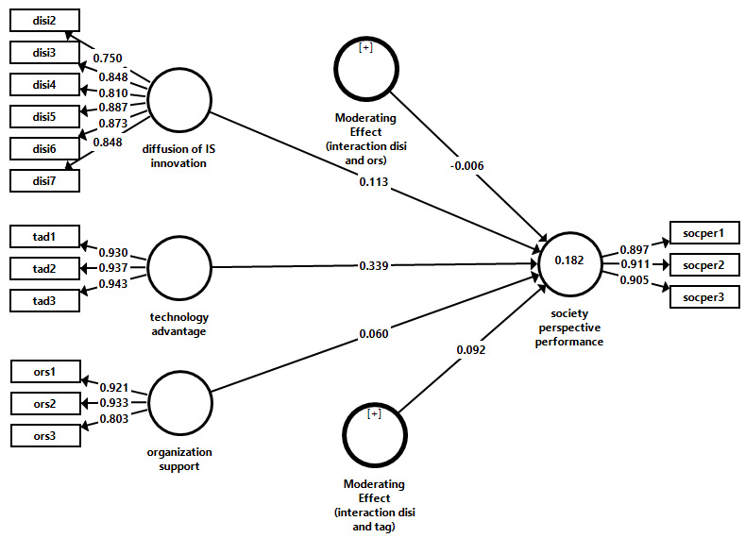 | 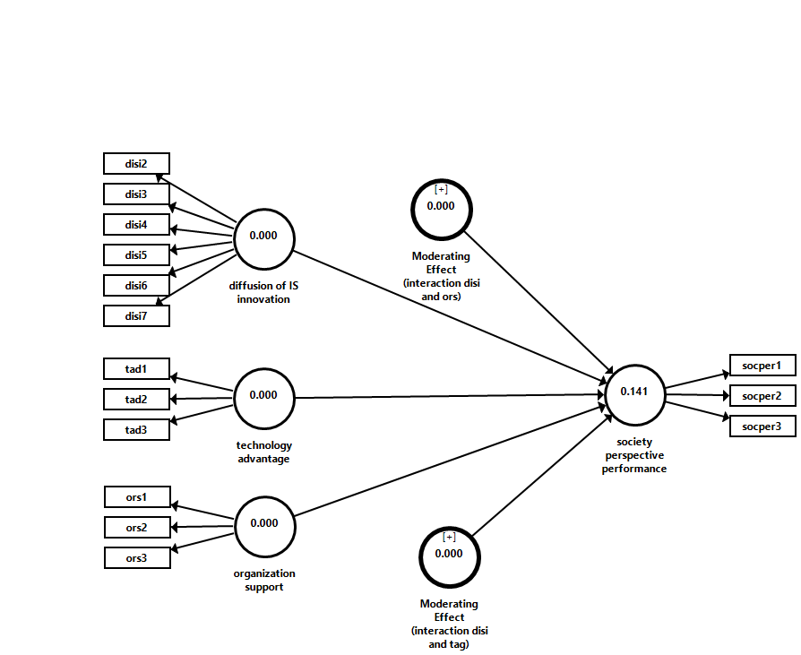
Figure 2. measurement model | Figure 3. blindfolding result (Q square)

The bootstrapping result is depicted in table 6 below. The first result informs the effect of the diffusion of IS innovation on society perspective performance. The p-value indicates above 0.05 (β=0.113, p-value=0.113), and it can be concluded that there is no effect of the diffusion of IS innovation on society perspective performance. Hence, the second analysis is to see the impact of the organization's support on society's perspective performance. The p-value also indicates above 0.05 (β=0.060, p-value=0.592) and means that organisational support does not have a significant relationship with society's performance. Thus, the third analysis investigates the relationship between technology advantage and society's performance. The result shows that there is a significant association between technology advantage and society perspective performance (β=0.339, p-value=0.002) at 1%. The direction of the relationship is positive. Thus, it means that high technology advantage improves society's perspective performance. The role of the organization support and technology advantage as moderating variables is not documented empirically due to their p-value greater than 5%. The detail of the bootstrapping result can be seen in table 7 and figure 4 for the structural model.

Table 7. Bootstrapping result
Relationship | Original Sample (O) | T Statistics (|O/STDEV|) | P Values | Decision
Moderating Effect (interaction disi and ors) -> society perspective performance | -0.006 | 0.096 | 0.923 | Not supported
Moderating Effect (interaction disi and tag) -> society perspective performance | 0.092 | 1.578 | 0.115 | Not supported
diffusion of IS innovation -> society perspective performance | 0.113 | 1.425 | 0.155 | Not supported
organization support -> society perspective performance | 0.060 | 0.536 | 0.592 | Not supported
technology advantage -> society perspective performance | 0.339 | 3.177 | 0.002 | Supported

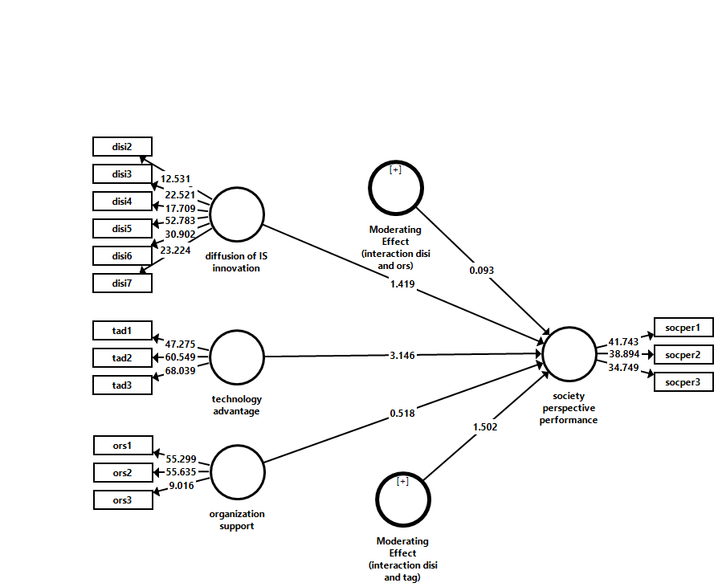
Figure 4. Structural model

Discussion
The relationship between diffusion of IS innovation and the performance of the village government.

The first finding indicates no significant effect on IS innovation diffusion and performance. The result is not aligned with the past research finding (Palm, 2022; Ranganathan et al., 2004; Tanriverdi, 2005; Wu & Chuang, 2010; Wu & Chen, 2014; Zaitul et al., 2022). Therefore, the village government has a diffusion process and implementation of the technology. Still, this diffusion did not create change by improving the performance and effectiveness as expected by an expert (Moghavvemi et al., 2012). İn addition, this diffusion of IS innovation failed to create a unique and valuable resource to improve the village government's performance, as suggested by the previous researcher (Wu & Chen, 2014). Therefore, this finding failed to confirm the resources-based theory (Barney, 1991).

The effect of the Technology advantage on the performance of the village government

there is a significant positive relationship between technology advantage and the performance of the village government. The TOE framework can explain this significant relationship. Therefore, the village government perceived the technology to benefit the government more (Rogers, 1995). İn addition, the village government evaluated the advantage of new technology before they adopted it (Premkumar & Roberts, 1999). Hence, technology adoption in village government is perceived as reduced turn-around time; better customer service declined cost and time information available for decision making (Premkumar & Roberts, 1999). This finding is consistent with previous works (Eisend et al., 2016; Erskine et al., 2019; Japutra et al., 2022; Wu & Chen, 2014) and contradict the finding of (Zaitul et al., 2022), who found that there is a direct relationship the technology advantage and performance of the village based tourism government. Eisend et al. (2016) found that the relative advantage of marketing over technology capabilities influences new product performance. Hence, Erskine et al. (2019) conclude that technology advantage (using heats map) contributes to the task technology fit and decision-making performance. Finally, Japutra et al. (2022) found that the relative advantage improves customer enggagement behavior wiht mobile commerce applications and affects marketing performance.

Technology advantage moderates the relationship between IS innovation diffusion and the performance of the village government

The role of TOE variables (technology advantage) fails to moderate the relationship between IS innovation diffusion and the performance of the village government. Therefore, these findings are inconsistent with previous results (García-Sánchez et al., 2018; Hsu et al., 2018; Wu & Chen, 2014; Zaitul et al., 2022). Wu and Chen (2014) conclude that the technology advantage play is moderating role between IS innovation diffusion and performance.

The influence of organization support on the performance of the village government

The third finding asserts that organisational support does not impact the village government's performance. These findings are supported by previous researchers (Elbanna & Newman, 2022; García-Sánchez et al., 2018; Hsu et al., 2018; Jane Lenard et al., 2014). İn addition, Wu and Chen (2014) conclude that organisational support plays a role during IS innovation diffusion, significantly affecting performance. García-Sánchez et al. (2018) found that there is a role of top management support (organization support) toward performance measured by reverse logistics. Hence, Hsu et al. (2018) also found that top management support contributes to service innovation. Finally, top management support is also found in digital transformation (Elbanna & Newman, 2022). This finding also indicates that the organization did not provide a long-term strategic vision, initiative, support, and commitment to creating a positive environment for innovation (Mcginnis & Ackelsberg, 1983). Therefore, this study fails to confirm the Theory of Technolgy Organization environment (Tornatzky & Fleischer, 1990).

Organization support moderates the relationship between IS innovation diffusion the performance of the village government

The role of TOE variables (Organisation support) also fails to moderate the relationship between IS innovation diffusion and the performance of the village government. İn addition, Wu and Chen (2014) also documented the role of organization support as moderating variable between IS innovation diffusion and performance (Wu & Chen, 2014). İn addition, top management support also plays a moderating variable between technological skill and reverse logistics as a proxy for performance (García-Sánchez et al., 2018). Finally, Hsu et al. (2018) found that top management support also moderates the relationship between the openness of technology adoption and service innovation. Therefore, this study fails to confirm that the integration of TOE and resources-based theory can solve the performance problem of the village government.

CONCLUSION AND RECOMMENDATION

There are a bundle of studies regarding the IS innovation diffusion and performance of the organization. İn fact, the previous survey also analyses the role of the variables from TOE as moderating variables between this diffusion and performance. However, the previous study pays less attention to the public sector organization, such as the village government. This study aims to see the role of a resources-based view and technology organization environment in explaining variation in village government performance. Specifically, this study analyzes the effect of IS innovation diffusion on the performance of the village government. Besides, this study also determines the role of organisational support and technology advantage in determining performance. Finally, this study also researched these variables as moderating variables between IS innovation diffusion and performance. The result shows that one hypothesis supported that the technology advantage is significantly associated with the performance of the village government. This finding theoretically contributes to the technology organization environment. Practically, this finding can be used by the village government to improve performance. Therefore, they must use the new technology to communicate better with the partner institution, provide timely information for decision-making, and support the village government to improve performance. This study has several limitations and offers future research avenues. First, this study was conducted in one city with a limited sample. Therefore, the next investigator can expand the area scope and the sample size to have a robust result. Second, this study analyzes the performance of the village government from limited variables from RBV and TOE. Thus, future research can expand this research by adding other variables from these theories. Finally, this study explains the performance of the village government from these two theories. Hence, future research can see why the village government's performance varies from other perspectives such as resources dependent theory or agency theory.

ACKNOWLEDGEMENT
The author acknowledges the Director General of Higher Education, Ministry of Education and Culture Republic of Indonesia, Number: 076/E5/PG.02.00.PT/2022, 069/LPPM-/Hatta-P/VI-2022 signed on June 16th 2022. We also thank the Rector of Universitas Bung Hatta for motivation.

REFERENCES
Adiputra, I. M. P., Utama, S., & Rossieta, H. (2018). Transparency of local government in Indonesia. Asian Journal of Accounting Research, 3(1), 123–138. https://doi.org/10.1108/ajar-07-2018-0019
Antlöv, H., Wetterberg, A., & Dharmawan, L. (2016). Village governance, community life, and the 2014 village law in Indonesia. Bulletin of Indonesian Economic Studies, 52(2), 161–183. https://doi.org/10.1080/00074918.2015.1129047
Bagozzi, R. R., & Yi, Y. (1988). On the Evaluation of Structural Equation Models. Journal of the Academy of Marketing Science, 16(1), 74–94.
Barney, J. B. (1991). Firm Resources and Sustained Competitive Advantage. Journal of Management, 17(1), 99–120. https://doi.org/10.1177/014920639101700108
Bharadwaj, A. S. (2000). A resource-based perspective on information technology capability and firm performance: an empirical investigation. MIS Quarterly, 24(1), 169–196.
Chin, W. W. (1998). The partial least squares approach to structural equation modeling in G. A. Marcoulides (Ed.). In Modern methods for business research (pp. 295–236). Lawrence Erlbaum Associates.
Cohen, J. (1992). Quantitative methods in psychology. Psychology Bulletin, 112(1), 155–159.
Eisend, M., Evanschitzky, H., & Calantone, R. J. (2016). The Relative Advantage of Marketing over Technological Capabilities in Influencing New Product Performance : Institutions. Journal of International Marketing, 24(1), 41–56. https://doi.org/10.1509/jim.15.0068
Elbanna, A., & Newman, M. (2022). The bright side and the dark side of top management support in Digital Transformaion – A hermeneutical reading. Technological Forecasting & Social Change, 175, 121411. https://doi.org/10.1016/j.techfore.2021.121411
Ellingson, D. A., & Wambsganss, J. R. (2001). Modifying the approach to planning and evaluation in governmental entities: “A balanced scorecard” approach. J. Public Budg. Account. Financ. Manag., 13(1), 103–120.
Erskine, M. A., Khojah, M., & Mcdaniel, A. E. (2019). Location Selection using Heat Maps : Relative Advantage , Task- Technology Fit , and Decision-Making Performance. Computers in Human Behavior, 101, 151–162. https://doi.org/10.1016/j.chb.2019.07.014
Fichman, R. G. (2001). The Role of Aggregation in the Measurement of IT-Related Organizational Inovation. MIS Quarterly, 25(4), 401–429. https://doi.org/10.2307/3250990
Fornell, C., & Larcker, D. F. (1981). Structural Equation Models with Unobservable Variables and Measurement Error: Algebra and Statistics. Journal of Marketing Research, 18(3), 382. https://doi.org/10.2307/3150980
Frost, D. E. (2019). Advanced Information Technology: Improve Workplace Productivity with Balanced Scorecard Actions. In Advances in the Technology of Managing People: Contemporary Issues in Business (pp. 51–67). https://doi.org/10.1108/978-1-78973-073-920191005
García-Sánchez, E., Guerrero-villegas, J., & Aguilera-Caracuel, J. (2018). How Do Technological Skills Improve Reverse Logistics ? The Moderating Role of Top Management Support in Information Technology Use and Innovativeness. Sustainability, 11(1), 1–17. https://doi.org/10.3390/su11010058
Grant, R. M. (1991). A Resource based theory of competitive advantageL implications for strategy formulation. California Management Review, 33(3), 114–135. https://doi.org/10.2307/41166664
Grover, V., & Goslar, M. D. (1993). The Initiation , Adoption , and Implementation of Telecommunications Technologies in U . S . Organizations. Journal of Management Information Systems, 10(1), 141–163. https://doi.org/10.1080/07421222.1993.11517994
Hair, J. F., Hult, G. T. M., Ringle, C. M., & Sarstedt, M. (2017). A primer on partial least squares structural equation modeling (PLS-SEM). SAGE Publication. https://doi.org/10.1017/CBO9781107415324.004
Henseler, Jörg. (2010). On the convergence of the partial least squares path modeling algorithm. Computational Statistics, 25(1), 107–120. https://doi.org/10.1007/s00180-009-0164-x
Henseler, Jorg, Ringle, C. M., & Sinkovics, R. R. (2009). The use of partial least squares path modeling in international marketing. Advances in International Marketing, 20, 277–319. https://doi.org/10.1108/S1474-7979(2009)0000020014
Hoque, Z., & Adams, C. (2011). the Rise and Use of Balanced Scorecard Measures in Australian Government Departments. Financial Accountability & Management, 27(3), 308–334. https://doi.org/10.1111/j.1468-0408.2011.00527.x
Hoque, Z., & James, W. (2000). Linking Balanced Scorecard Measures to Size and Market Factors : Impact on Organizational Performance. Journal of Management Accounting Research, 12(1), 1–17.
Hossain, M. N., Talukder, M. S., Hoque, M. R., & Bao, Y. (2018). The use of open government data to citizen empowerment: an empirical validation of a proposed model. Foresight, 20(6), 665–680. https://doi.org/10.1108/FS-03-2018-0027
Hsu, H.-Y., Liu, F.-H., Tsou, H.-T., & Chen, L.-J. (2018). Openness of technology adoption , top management support and service innovation : a social innovation perspective. Journal of Business & Industrial Marketing, 34(3), 575–590. https://doi.org/10.1108/JBIM-03-2017-0068
Hulland, J. (1999). Use of partial least square (PLS) in strategic management research: a review of four recent studies. Strategic Management Journal, 20, 195–204.
Jane Lenard, M., Yu, B., Anne York, E., & Wu, S. (2014). Impact of board gender diversity on firm risk. Managerial Finance, 40(8), 787–803. https://doi.org/10.1108/MF-06-2013-0164
Japutra, A., Molinillo, S., Utami, A. F., & Ekaputra, I. A. (2022). Exploring the effect of relative advantage and challenge on customer engagement behavior with mobile commerce applications. Telematics and Informatics, 72, 101841.
Kaplan, R. S., & Norton, D. P. (1992). The balanced scorecard — Measures that drive performance. Harvard Business Review, January-Fe, 71–79.
Kline, R. B. (1998). Principles and Practice of Structural Equation Modeling. Guilford Press.
Lederer, B. A. L., & Mendelow, A. L. (1988). Convincing Top Management of the Strategic Potential of Information Systems. MIS Quarterly, 12(4), 525–534.
Lee, S., & Kim, K. (2007). Factors affecting the implementation success of Internet-based information systems. Computers in Human Behavior, 23(4), 1853–1880. https://doi.org/10.1016/j.chb.2005.12.001
Lee, Y., & Moon, J. (2008). An Exploratory Study on the Balanced Scorecard Model of Social Enterprise. Asian Journal on Quality, 9(2), 11–30. https://doi.org/10.1108/15982688200800014
Maiga, A. S., & Jacobs, F. A. (2003). Balanced scorecard , activity-based costing and company performance : An empirical analysis. Journal of Managerial Issues, 15(3), 283–301.
Mcginnis, M. A., & Ackelsberg, M. R. (1983). Effective innovation management : missing link in strategic planning ? Journal of Business Strategy, 4(1), 59–66.
Mergel, I. (2013). A framework for interpreting social media interactions in the public sector. Government Information Quarterly, 30(4), 327–334. https://doi.org/10.1016/j.giq.2013.05.015
Meyer, A. D., & Goes, J. B. (1988). Organizational assimilation of innovations : a multilevel contextual analysis. Academy of Management Journal, 31(4), 897–923.
Moghavvemi, S., Salleh, N. A. M., Zhao, W., & Mattila, M. (2012). The entrepreneur’s perception on information technology innovation adoption: An empirical analysis of the role of precipitating events on usage behavior. Innovation: Management, Policy and Practice, 14(2), 231–246. https://doi.org/10.5172/impp.2012.14.2.231
Palm, A. (2022). Innovation systems for technology diffusion : An analytical framework and two case studies. Technological Forecasting & Social Change, 182(March 2021), 121821. https://doi.org/10.1016/j.techfore.2022.121821
Premkumar, G., & Roberts, M. (1999). Adoption of new information technologies in rural small businesses. Omega, Int. J. Mgmt. Sci, 27(4), 467–484.
Rajagopal, P. (2002). An innovation -diffusion view of implementation of enterprise resource planning (ERP) systems and development of a research model. Information & Management, 40, 87–114.
Ranganathan, C., Dhaliwal, J. S., & Teo, T. S. H. (2004). Assimilation and Diffusion of Web Technologies in Supply-Chain Management : An Examination of Key Drivers and Performance Impacts. International Journal of Electronic Commerce, 9(1), 127–161. https://doi.org/10.1080/10864415.2004.11044319
Roengtam, S., Nurmandi, A., Almarez, D. N., & Kholid, A. (2017). Does social media transform city government? A case study of three ASEAN cities: Bandung, Indonesia, Iligan, Philippines and Pukhet, Thailand. In Transforming Government: People, Process and Policy (Vol. 11, Issue 3). https://doi.org/10.1108/TG-10-2016-0071
Rogers, E. M. (1995). Diffusion of Innovation (4th editio). The Free Press.
Rogers, E. M. (2003). Diffusion of Innovations (5th ed). Free Press.
Santhanam, R., & Hartono, E. (2003). Issues in Linking Information Technology Capability to Firm Performance. MIS Quarterly, 27(1), 125–153.
Solano, J., Ovalles, M. P. De, Rojas, T., Padua, A. G., & Morales, L. M. (2013). Integration of systemic quality and the balanced scorecard. Information System Management, 20(1), 64–79.
Swanson, E. B., & Ramiller, N. C. (2004). Innovation mindfully with information technology. MIS Quarterly, 28(4), 553–583.
Tanriverdi, H. (2005). Information technology relatednes, knowledge management capability, performance of multibusiness firms. MIS Quarterly, 29(2), 311–334.
Tornatzky, & Fleischer, M. (1990). The processes of technological innovation. Lexington Books.
Vinzi, V. E., Chin, W. W., Henseler, J., & Wang, H. (2010). Handbook of Partial Least Square: Concepts, Methods and Applications. Springer. https://doi.org/10.1007/978-3-540-32827-8
Wade, M., & Hulland, J. (2004). Review : The resource-based view and information systems research : Review , extension , and suggestions for future research. MIS Quarterly, 28(1), 107–142.
Wang, Y., Wang, Y., & Yang, Y. (2010). Technological Forecasting & Social Change Understanding the determinants of RFID adoption in the manufacturing industry. Technological Forecasting & Social Change, 77(5), 803–815. https://doi.org/10.1016/j.techfore.2010.03.006
Wu, I., & Chuang, C. (2010). Examining the diffusion of electronic supply chain management with external antecedents and fi rm performance : A multi-stage analysis. Decision Support Systems, 50(1), 103–115. https://doi.org/10.1016/j.dss.2010.07.006
Wu, I. L., & Chen, J. L. (2014). A stage-based diffusion of IT innovation and the BSC performance impact: A moderator of technology-organization-environment. Technological Forecasting and Social Change, 88, 76–90. https://doi.org/10.1016/j.techfore.2014.06.015
Yeniyurt, S. (2003). A literature review and integrative performance measurement framework for multinational companies. Marketing Intelligence & Planning, 21(3), 134–142. https://doi.org/10.1108/02634500310474957
Zaitul, Ilona, D., Novianti, N., & Widiningsih, F. A. (2022). Difusi inovasi sistim informasi dan kinerja proses internal pemerintahan desa destinasi wisata: kebermanfaatan teknologi sebagai variabel moderasi. Proseding Seminar Nasional LICOVBITECH Di Politeknik LP3I Jakarta, Sabtu 17 September 2022, 1, 2022.
Zavattaro, S. M., & Brainard, L. A. (2019). Social media as micro-encounters: Millennial preferences as moderators of digital public value creation. International Journal of Public Sector Management, 32(5), 534–552. https://doi.org/10.1108/IJPSM-02-2018-0059

Corresponding author

