IDENTIFICATION OF SUB-SURFACE ROCK STRUCTURES
IN THE BANYU BIRU HOT SPRINGS AREA
USING THE GRAVITY METHOD
Ahmad Luthfin¹, Aisyatin Kamilah² and Irjan³
^{1,2,3} Jurusan Fisika, Universitas Islam Negeri Maulana Malik Ibrahim Malang
Jl. Gajayana No. 50 Malang 65144
e-mail: ahmadluthfin@fis.uin-malang.ac.id
* Corresponding Author

Abstract
One of the geothermal manifestations in Nganjuk is the Banyu Biru hot spring in Gondangwetan Village, Jatikalen District, Nganjuk regency. This hot spring was discovered by accident when drilling a well to be used as a rice field flow, but the water that came out was hot water with a temperature of 37 oC at a depth of 250-300 m. This study aims to determine local anomaly patterns and lithological structures of subsurface rocks in the Jatikalen hot spring area. The research method used is the gravity method based on GGMPlus satellite data obtained as many as 100 data with a distance of 200 m between points. Based on the qualitative analysis of the local anomaly contours, the low anomaly was -2.6 mGal to -0.8 mGal, the moderate anomaly was -0.6 mGal to 2.2 mGal, and the high anomaly was 0.6 mGal – 2.2 mGal. Quantitative interpretation with the results of the cross-sectional model resulted in 5 layers of topsoil with a density value of 1.2 grams/cm³. In the second layer is alluvium in the form of gravel, gravel, sand with a density of 1.7 grams/cm3. The third layer is tuffaceous clay with a density of 2 grams/cm3 and the fourth layer is calcareous tuff with a density value of 2.67 grams/cm³. While the last in the fifth layer is breccia rock with a density value of 3 grams/cm³.
Keywords: Geothermal, Gravity method, Lithology

INTRODUCTION
In Indonesia, there are 256 geothermal areas with the potential to generate power up to 27,441 MW(Afandi, Maryanto and Susilo, 2012). Geothermal is one of the renewable energies which is abundant in Indonesia(Iqbal et al., 2019). Geothermal in East Java is spread over 13 points, one of which is in WKP Gunung Pandan, geothermal in Gunung Pandan which is designated as WKP with Decree No. 2774 K/30/ME/2014 dated 03-06-2014 covering the areas of Bojonegoro, Madiun, and Nganjuk. Where Nganjuk regency is located between the slopes of Mount Wilis to the south and to the north of Mount Pandan
The existence of a geothermal system with existing signs such as the emergence of hot springs, steam bursts, hot mud, sulfur sublimation, and alteration of rocks that penetrate the earth's surface rocks through fractures / faults is a geothermal manifestation (Zarkasyi and Rezky, 2011)(Zain et al., 2015)(Octavani, no date). . One of the geothermal manifestations in Nganjuk is the Banyu Biru hot spring in Gondangwetan Village, Jatikalen District, Nganjuk Regency. The beginning of this hot spring was because the wells were drilled to be used as rice fields, but the water that came out was hot water with a depth of 250-300 meters which has a hot temperature of around 37 ° C.
The existence of a natural phenomenon in the form of geothermal needs to be carried out a study with the aim of knowing the structure of the subsurface rock in the area and the local government is planning to develop geothermal drilling. To model the rock density features, one of the geophysical methods is used, namely gravity.(Sarkowi et al., 2021)(Zain et al., 2015) (Ismail et al., 2018)
The results of this study are expected to provide information about the rock structure below the surface which may be the escape route for geothermal fluids in the study area.
The Theory of Gravity is based on Newton's law which states that the force of attraction that occurs between the masses of two objects is proportional and inversely proportional to the distance between the centers of mass of the two objects(Oesanna and Ismail, 2018)(Raji, 2014): .
(1)
Where the gravitational constant (G) = 6.67 x 10⁻¹¹ N.m². Then equation 1 when substituted into equation 2 will get:
(2)
This last equation shows that the magnitude of the acceleration caused by the earth's gravity (g) will be directly proportional to the mass of the earth (M) and inversely proportional to the square of the earth's radius (R). The value of the earth's gravity in this theory is the same throughout the earth's surface. In fact, the value of gravity varies from place to place because of the flat shape of the earth due to the rotation of the earth, the topography of the earth's surface is also irregular and the distribution of mass varies, especially near the surface.(Nurwidyanto, 2007)
Several geophysical exploration methods can be applied to geothermal exploration, including the gravity method based on GGMplus satellite imagery data as an alternative solution in current research(Yanis, Marwan and Ismail, 2019). This method has the advantage of being quite accurate and relatively inexpensive(Putra, Arman and Zulfian, 2021). The data obtained from this method produces a better contrast when compared to other methods (Raehanayati, Rachmansyah and Maryanto, 2013).
Anomalous sources below the earth's surface can affect the value of the earth's gravitational acceleration and the gravitational field. The gravitational field due to anomalous sources with varying vertical directions is referred to as the anomalous source position. The value of the gravitational field changes due to an anomaly source whose value is smaller than the value of the earth's gravitational field which is called a gravitational anomaly(Marwan, Rusydy Ibnu , Nugraha Gartika Setiya, 2014).
Geology of the Research Area
The research location is on the plain morphological units that occupy the main watersheds, namely: the Brantas River, Konto River, Widas River, Brangkal River and Bangsal River with a stream pattern of twigs, semi-parallel, woven, and meanders. Morphological elevation up to 100 meters above sea level.
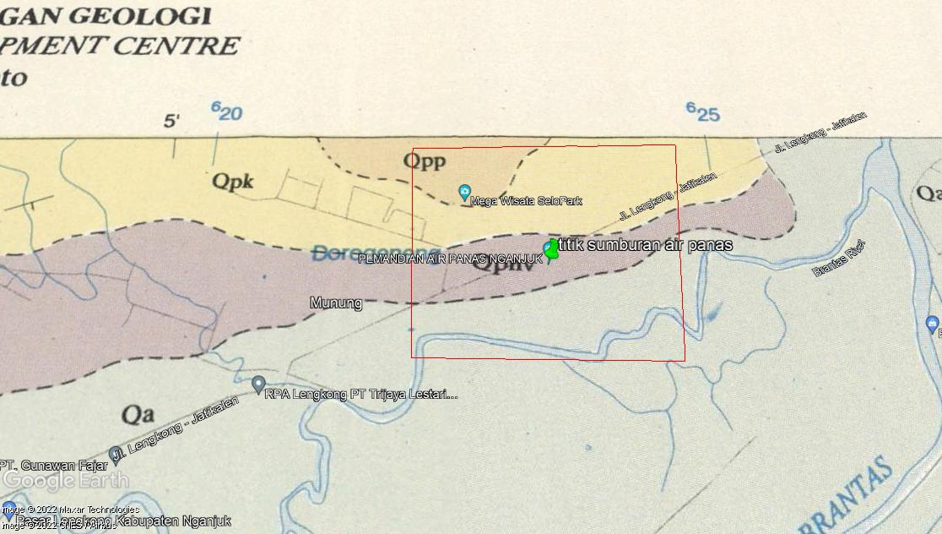
Figure 1. Geological map of the research area

The stratigraphy in the study area includes the Alluvim (Qa) formation with rocks composed of gravel, sand, clay, mud, and plant remains. The Notopuro Formation (Qpnv) is composed of breccia rocks, tuffaceous sandstones, tuffaceous slabs, calcareous sandstones and limestones. The Pucangan Formation (Qpp) is composed of breccias, sandstones, clay inserts, and conglomerates. While the last is the Kabuh Formation (Qpk) namely sandstone, claystone, conglomerate insertion and tuff.
METHODS
The location of the research was carried out around the Banyu Biru hot spring located in Gondangwetan Village, Jatikalen District, Nganjuk Regency. The boundary of the study area is 752 South Latitude 11210 East Longitude to 75 South Latitude 11212 East Longitude with an area of ​​2 km x 2 km.
The data used in this study is GGMPlus gravity data which is a type of secondary data that can be accessed on the web http://murraylab.caltech.edu/GGMplus/index.html. The data obtained is in the form of gravity values ​​that have been corrected for free air (FAA).
The data is taken from the GGMPlus gravity data and then the free air and topographic anomaly values ​​are obtained. Furthermore, Bouguer correction and field correction are performed to produce the Complete Bouguer Anomaly (CBA) value(Mantlík et al., 2009). Mathematically the Complete Bouguer Anomaly (CBA) can be calculated using the following formula (Nurwidyanto, Yulianto and Widada, 2019)
where g0 is an observation gravity value, BC is bouguer correction, TC is terrain correction, gn is normal gravity. normal gravity values that can be written with equations
(
Then the plane reduction is performed using the Dampney approach in Matlab 2013 software. Then, upward continuation is performed to separate local and regional anomalies. The last step is modeling on the oasis montaj software to model the conditions below the surface by matching the geological information of the research area.
The interpretations carried out are qualitative and quantitative. This qualitative interpretation provides very useful information as a constraint for quantitative interpretation in order to get a detailed geothermal geological model(Lewerissa, 2021). While the quantitative interpretation can be done by analyzing the cross section of the anomalous pattern along a certain path that has been determined by cutting the hot burst point. In this study, three anomalous sections were made, namely A-A', B-B', and C-C sections(Murty and Raghavan, 2002).

Results and Discussion
Based on the results of GGMPlus gravity data processing, a complete Bouguer Anomaly Contour Map is obtained. In general, the complete Bouguer Anomaly describes the condition of the subsurface rock density distribution related to the local geology.
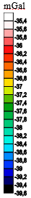

Figure 2. Complete Bouguer Anomaly Contour Map

Complete Bouguer Anomaly values ​​ranged from -39.5 mGal to -35.4 mGal with three different anomalous patterns. The low anomaly with blue color is located in the northwest to the south with an anomaly value of -39.6 mGal to -38.2 mGal. Medium anomaly with green color which is located spread around the study area with anomaly value of -38 mGaal to -36.8 mGal. The high anomaly with red color located in the northwest part is with a value of -36.4 mGal to -35.4 mGal.
The Bouguer anomaly value is the result of several corrections in the form of values ​​that are still exposed to the topography which are located at irregular points.
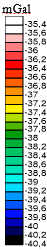
Figure 3. Contour Anomaly After Flat Plane Reduction
On the reduced contour, the flat plane shows a contour similar to the complete Bouguer anomaly with a slightly lower anomaly value than the Complete Bouguer anomaly before being reduced. The results of the reduction of the flat plane still contain regional anomalies and residual anomalies, so that to interpret the geology, residual anomalies are needed from the separation (Purnomo, Koesuma and Yunianto, 2016).
Bouguer anomaly into regional anomaly and residual anomaly, with the continuation method above, so that the regional anomaly and residual anomaly values ​​are obtained. Anomaly resulting from flat plane reduction is still a mixture of regional anomalies and residual anomalies
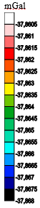
Figure 4. Contour Results Upward Continuation
Regional anomaly values ​​obtained are between -37.868 mGal to -37.8605 mGal with a difference of 0.0005 mGal anomaly value. If you see from the picture above, there are no more closed closures.
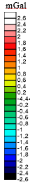
Figure 5. Contour of Local Anomaly Resulting Upward Continuation
mGal
In this study, there are negative and positive anomaly values, positive values ​​indicate that the density value in the subsurface rock structure is of high value. Conversely, if the anomaly is negative, it indicates that the density in the rock below the surface is of low value. The greater the value of gravity, the denser the rock below the surface, such as geological structures in the form of faults or faults that have low gravity values ​​because they have cavities associated with low rock density, his indicates the presence of rock lithology that has a high porosity value or low density(Sihombing and Rustadi, 2020)(Sarkowi, 2010)
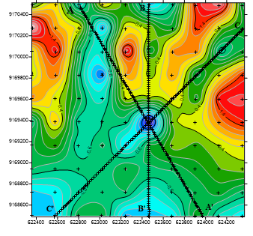
.
Figure 6. Profile of A-A', B-B', and C-C' Slices on Local Anomaly Contours

Interpretation is carried out based on Figure 4.25 on the local anomaly which is sliced ​​with reference to the point of the water spout. In this interpretation, modeling of 3 cross sections is carried out, namely cross sections A-A', B-B', and C-C'. Quantitative interpretation is carried out based on the results of qualitative interpretation so that it can determine the interesting anomaly cross sections for interpretation of geological structures. The three cross sections of the slice are as follows:

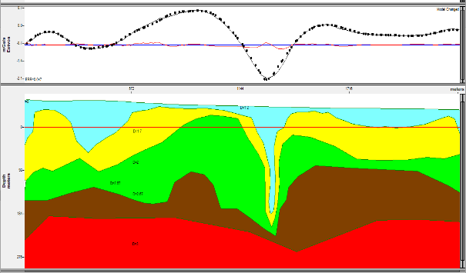
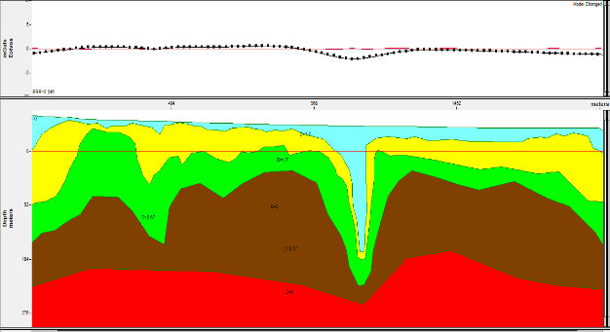
(a)

(b)

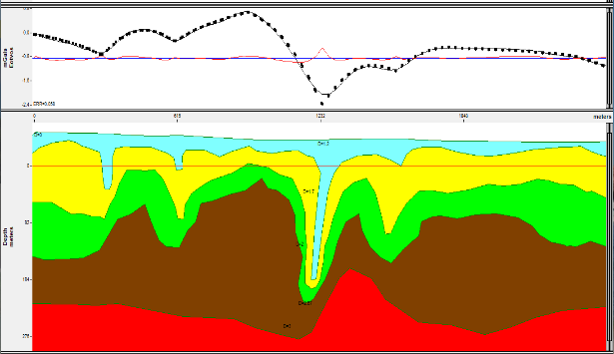

(C)
Figure 7. (a) Subsurface 2D Model in A-A' (b) incision. Subsurface 2D Model at Incision B-B' (c) Subsurface 2D Model at Incision B-B'

It can be seen based on Figure 6 on the modeling of the subsurface cross-section which consists of 5 layers. The first layer is light blue as the top layer which is interpreted as topsoil (soil) which has a density value of 1.2 grams/cm³ with a thickness of 5 meters above sea level starting from 214-225 meters below sea level. The modeling results show a low density block that coincides with the fault zone, considered as fracture rock that fills the fault zone [2]. In the second layer, yellow is interpreted as alluvium in the form of gravel, gravel, sand which has a density of 1.7 grams/cm3 in. with a thickness of 10 meters above sea level to 126 meters below sea level. In the third layer, which is green, it is interpreted as tuffaceous clay with a density of 2 grams/cm³ which is included in the Kabuh Formation with a thickness of 10-195 meters below sea level, in another study the value of tuff density ranged from 2.09 grams/cm³ (Wangsa, Ismail and Marwan, 2018). In the fourth layer, dark brown color is interpreted as calcareous tuff with a density of 2.67 grams/cm³ in the Notopuro Formation with a depth of 13 meters to 188 meters below sea level. In the last layer, the fifth, which is red, is interpreted as a breccia with andesite and basal components with a density of 3 grams/cm³ and is included in the Pucangan Formation with a thickness of 20 meters to 134 meters below sea level. The results of this modeling are in accordance with the existing stratigraphic table, as shown below.

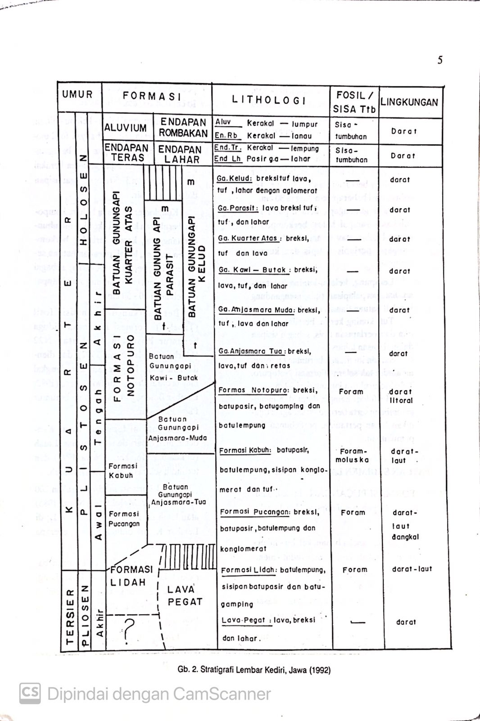
Figure 8 Stratigraphy table Kediri, Java
The stratigraphy in the study area includes the Alluvim (Qa) formation with rocks composed of gravel, gravel, sand, clay, mud, and plant remains. The Notopuro Formation (Qpnv) is composed of breccia rocks, tuffaceous sandstones, tuffaceous slabs, calcareous sandstones and limestones.
Based on existing geological data maps. It is suspected that the reservoir is in the second layer, namely alluvium which consists of gravel, gravel, and sand because it has a coarse component or the rock is coarse and the sand itself has a high permeability. For the supporting rock, it is in the third layer of tuffaceous clay because the clay itself has a smooth texture so that it is thought to be able to hold water in alluvium. Hot water in the earth's crust changes rock minerals into clay rock (argillic alteration) which over time forms a waterproof cap rock, so hot water is difficult to rise to the surface. The trapped water can be held in the presence of clay that can hold water because of its smooth texture. While the nature of the tuff rock is rough so it has a large permeability and this rock also contains the presence of chlorite which helps improve the quality of the reservoir rock. While in the formation at the bottom, there are breccia rocks with andesite and basalt components. So that the heat source is thought to come from andesite rocks so that it propagates to the upper layer where andesite is very easily convective because it has a very high porosity. So it can be assumed that water can be trapped in high pores which allows a heating process when it comes into contact with hot rock which then becomes hydrothermal.
Conclusion
Based on the results of modeling in the hot spring area, it can be concluded that in general there are 5 constituent layers. Where the first layer is topsoil with a density value of 1.2 grams/cm³. In the second layer is alluvium in the form of gravel, gravel, sand with a density of 1.7 grams/cm³. The third layer is tuff aceous clay with a density of 2 grams/cm3 and the fourth layer is calcareous tuff with a density value of 2.67 grams/cm³. While the last in the fifth layer is breccia rock with a density value of 3 grams/cm³

Bibliography

Afandi, A., Maryanto, S. and Susilo, A. (2012) ‘Geomagnetic Survey In Cangar Area, Batu City, East Java To Assess the Potential of Geothermal’, Natural-B, 1(3), pp. 288–296. Available at: https://doi.org/10.21776/ub.natural-b.2012.001.03.15.
Iqbal, M. et al. (2019) ‘Delineation of Recharge and Discharge Area for Geothermal Energy in Natar’, IOP Conference Series: Earth and Environmental Science, 258(1). Available at: https://doi.org/10.1088/1755-1315/258/1/012036.
Ismail, N. et al. (2018) ‘Mapping buried ancient structure using gravity method: A case study from Cot Sidi Abdullah, North Aceh’, Journal of Physics: Conference Series, 1120(1). Available at: https://doi.org/10.1088/1742-6596/1120/1/012035.
Lewerissa, R. (2021) ‘Overview of Geothermal Potential in Momiwaren, South Manokwari Regency using Earth Gravity Field Analysis’, Kasuari: Physics Education Journal (KPEJ), 3(2), pp. 97–109. Available at: https://doi.org/10.37891/kpej.v3i2.142.
Mantlík, F. et al. (2009) ‘The use of gravity methods in the internal characterization of landfills - A case study’, Journal of Geophysics and Engineering, 6(4), pp. 357–364. Available at: https://doi.org/10.1088/1742-2132/6/4/003.
Marwan, Rusydy Ibnu , Nugraha Gartika Setiya, A. (2014) ‘Study of Seulawah Agam ’ s Geothermal Source Using Gravity Method’, Natural, 14(2), pp. 1–5. Available at: https://doi.org/10.17969/jn.v14i2.2252.
Murty, B.V.S. and Raghavan, V.K. (2002) ‘The gravity method in groundwater exploration in crystalline rocks: A study in the peninsular granitic region of Hyderabad, India’, Hydrogeology Journal, 10(2), pp. 307–321. Available at: https://doi.org/10.1007/s10040-001-0184-2.
Nurwidyanto (2007) ‘Pemodelan Zona Sesar Opak Di Daerah Pleret Bantul Yogyakarta Dengan Metode Gravitasi’, Berkala Fisika, 10(1), pp. 65–70.
Nurwidyanto, M.I., Yulianto, T. and Widada, S. (2019) ‘Modeling of semarang fault zone using gravity method’, Journal of Physics: Conference Series, 1217(1). Available at: https://doi.org/10.1088/1742-6596/1217/1/012031.
Octavani, A.S. (no date) ‘1687-3744-1-sm (3)’, (3).
Oesanna, M. and Ismail, N. (2018) ‘Locating of Fault Zone at the Western of Seulawah Agam volcano Using Gravity Method’, Journal of Aceh Physics Society, 7(2), pp. 56–60.
Purnomo, J., Koesuma, S. and Yunianto, M. (2016) ‘Pemisahan Anomali Regional-Residual pada Metode Gravitasi Menggunakan Metode Moving Average, Polynomial dan Inversion’, Indonesian Journal of Applied Physics, 3(01), p. 10. Available at: https://doi.org/10.13057/ijap.v3i01.1208.
Putra, N.S., Arman, Y. and Zulfian (2021) ‘Identifikasi Struktur Bawah Permukaan Daerah Potensi Panas Bumi Pada Lembar Kota Agung Menggunakan Data Global Gravity Model Plus ( GGMplus )’, Prisma Fisika, 9(2), pp. 183–189.
Raehanayati, R., Rachmansyah, A. and Maryanto, S. (2013) ‘Studi Potensi Energi Geothermal Blawan- Ijen, Jawa Timur Berdasarkan Metode Gravity’, Jurnal Neutrino, p. 31. Available at: https://doi.org/10.18860/neu.v0i0.2444.
Raji, W.O. (2014) ‘Review of Electrical and Gravity Methods of Near-Surface Exploration for Groundwater’, Nigerian Journal of Technological Development, 11(2), pp. 31–38.
Sarkowi, M. (2010) ‘Identifikasi struktur daerah panasbumi ulubelu berdasarkan analisa data svd anomali bouguer’, J. Sains MIPA, 16(2), pp. 111–118.
Sarkowi, M. et al. (2021) ‘Wai Selabung geothermal reservoir analysis based on gravity method’, Jurnal Ilmiah Pendidikan Fisika Al-Biruni, 10(2), pp. 211–229. Available at: https://doi.org/10.24042/jipfalbiruni.v10i2.9705.
Sihombing, R.B. and Rustadi, R. (2020) ‘Pemodelan Dan Analisa Struktur Bawah Permukaan Daerah Prospek Panasbumi Kepahiang Berdasarkan Metode Gayaberat’, Jurnal Geofisika Eksplorasi, 4(2), pp. 47–61. Available at: https://doi.org/10.23960/jge.v4i2.14.
Wangsa, A., Ismail, N. and Marwan (2018) ‘Quantitative Interpretation of Gravity Anomaly Data in Geothermal Field Seulawah Agam, Aceh Besar’, J. Aceh Phys. Soc, 7(1), pp. 6–12. Available at: http://www.jurnal.unsyiah.ac.id/JAcPS.
Yanis, M., Marwan, M. and Ismail, N. (2019) ‘Efficient Use of Satellite Gravity Anomalies for mapping the Great Sumatran Fault in Aceh Province’, Indonesian Journal of Applied Physics, 9(02), p. 61. Available at: https://doi.org/10.13057/ijap.v9i2.34479.
Zain, M.A. et al. (2015) ‘Studi Penerapan Metode Analisis Derivatif Pada Data Potensial Gravitasi’, Prosiding Seminar Nasional Fisika 2015, IV, pp. 65–70. Available at: http://snf-unj.ac.id/kumpulan-prosiding/snf2015/.
Zarkasyi, A. and Rezky, Y. (2011) ‘Model Sistem Panas Bumi Berdasarkan Data Gravity Pada Daerah Songa - Wayaua, Pulau Bacan, Maluku Utara’, Buletin Sumber Daya Geologi, 6(1), pp. 33–40. Available at: https://doi.org/10.47599/bsdg.v6i1.99.

