Development And Implementation Mobile Virtual Laboratory on Prophetic Integrated Electrical Circuit Material
Imas Ratna Ermawati ¹, A Kusdiwelirawan ², Martin ³, Syiffa Nurul Sya’adah⁴,
Berliani Amanda Diningsih⁵
^{1,2,3,4,5}Department of Physics Education Universitas Muhammadiyah Prof. DR. HAMKA, Jakarta, Indonesia
e-mail: ^{1*} Imas_re@uhamka.ac.id ^{2*} kusdiwelirawan@uhamka.ac.id ^{3*}martin@uhamka.ac.id ^{4*}2001115001@uhamka.ac.id ^{5*}200115004@uhamka.ac.id

Abstrak
Pengembangan merupakan penelitian dengan luaran produk baik secara sederhana maupun struktural. Penelitian pengembangan digunakan untuk merancang serta menghasilkan suatu produk dengan secara sistematik dan memenuhi kriteria kepraktisan internal universal dan mempergunakan kerangka ilmu pengetahuan.Untuk mewujudkan mahasiswa pendidikan fisika tentunya melalui virtual laboratory yang sesuai dengan kebutuhan mahasiswa. Penelitian ini bertujuan untuk mengembangkan praktikum berbasis online / e-learning menggunakan virtual laboratory pada materi rangkaian listrik. Metode yang digunakan adalah Reseach and Development (R&D) dengan model Borg & Gall, produk yang dikembangkan berupa praktikum online /virtual laboratory. Sumber datanya yaitu mahasiswa pendidikan fisika pada FKIP UHAMKA . Sumber data diperoleh dari informan, dokumen, proses kegiatan dan validator. Teknik pengumpulan data dengan wawancara, angket, dan dokumentasi,sedangkan teknik analisis data menggunakan uji gain score, analisis deskriptif kuantitatif dan kualitatif.
Validasi model dilakukan dengan menggunakan penilaian pakar/ahli (expert judgement) dengan
menggunakan teknik delphi. Hasil Penelitian ini yaitu (1) model praktikum online /virtual laboratory; (2) pengembangan praktikum online / virtual laboratory rangkaian listrik dengan materi arus bolak-balik, ; (3) Model virtual laboratory rangkaian listrik layak diterapkan .Validasi dari ahli/ pakar akademisi materi , media dan praktisi berkaitan dengan model dan modul praktikum online adalah 85 dan 87,4 dengan kategori sangat baik. Virtual laboratory ditinjau dari profetik dengan menggunakan angket untuk mengukur profetik mahasiswa pada saat praktikum online maupun pengumpulan tugas praktikum. Kelayakan penggunaan virtual laboratory dengan nilai rata-rata 92% dengan kriteria baik saat menggunakan virtual laboratory ditunjukkan dengan nilai rata-rata keseluruhan untuk 4 (empat) prinsip profetik pengguna tingkat tinggi dengan rata-rata shidiq 8,64,Amanah / tanggung jawab dengan rata-rata 9,08 dan tabligh/ komunikatif dengan rata-rata 9,33 serta fathonah/ rasa ingin tahu dengan rata-rata 8,67. Rata-rata keseluruhan profetik adalah 8,93. Kesimpulannya adalah bahwa praktikum rangkaian listrik melalui virtual laboratory layak untuk melatih profetik dalam praktikum mahasiswa pada materi arus bolak-balik.
Kata kunci :Virtual Laboratory, Rangkaian Listrik , Profetik

Abstract
Development is research with product outputs both in simple and structural terms. Development research is used to design and produce a product systematically and meet the criteria of universal internal practicality and use a scientific framework. To realize physics education students, of course, through a virtual laboratory that suits student needs. This study aims to develop an online / e-learning based practicum using a virtual laboratory on electrical circuit material. The method used is Research and Development (R&D) with the Borg & Gall model, the product developed is in the form of an online/virtual laboratory practicum. The data sources are physics education students at FKIP UHAMKA. Sources of data obtained from informants, documents, process activities and validators. Data collection techniques are interviews, questionnaires, and documentation, while the data analysis techniques are using gain score test, quantitative and qualitative descriptive analysis. Model validation is carried out using expert judgment with using the Delphi technique. The results of this study are (1) online/virtual laboratory practicum model; (2) the development of an online/virtual laboratory practical electric circuit with alternating current material, ; (3) The electric circuit virtual laboratory model is feasible to apply. The validation from material academics, media and practitioners related to online practicum models and modules is 85 and 87.4 with very good categories. The virtual laboratory is viewed from a prophetic perspective by using a questionnaire to measure student's prophetic during online practicum and collecting practicum assignments. The feasibility of using a virtual laboratory with an average value of 92% with good criteria when using a virtual laboratory is indicated by the overall average value for 4 (four) high-level user prophetic principles with a shidiq average of 8.64, Trustworthiness / responsibility with an average average 9.08 and tabligh/communicative with an average of 9.33 and fathonah/curiosity with an average of 8.67. The overall average of prophetic is 8.93. The conclusion is that electric circuit practicum through a virtual laboratory is feasible to train prophetically in student practicum on alternating current material..
Keywords: Virtual Laboratory, Electrical Circuits , Prophetic

How to Cite: Ermawati, I. R., Kusdiwelirawan, A., Martin., Sya’dah, S. N.& Diningsih, B. A (20XX). Pengembangan Mobile Virtual Laboratory Rangkaian Listrik Terintegrasi Profetik. Jurnal Pendidikan Fisika dan Keilmuan (JPFK), 5(2), 5X-7X. doi:http://dx.doi.org/10.25273/jpfk.v5i2.50XX

INTRODUCTION
The development of information technology that occurs in this country is increasingly advanced along with the development of the global market era. The development of information technology is widely used to support human life. In the world of education, the presence of information technology is one of the choices in the implementation of educational programs. Utilization of the internet in the form of web-based learning media is one form of e-learning that is currently being developed by various educational institutions. Internet technology that is interactive, flexible, limited in space and time is expected to be one of the best learning media (Hardyanto & Surjono, 2016). Borg and Gall (1989: 782) in Fauzi et al. (2021) explained that "the research and development model is a process used to develop and validate educational products.". The objectives of research and development are to improve the quality of education, discover new knowledge (basic research), and answer questions about practical problems (applied research). (Fauzi et al., 2021). Development is a process for developing and validating a product with multiple objectives that can be accounted for. According to Kozma, the laboratory is used for teaching activities that require the practice of certain skills and/or direct experiences for students. Virtual laboratories can be a place to conduct experiments that cannot be done in conventional laboratories (Niken & Dany Haryanto, 2010). One of the principles of defining a virtual laboratory is that a virtual laboratory is not defined as a learning unit but a learning space, for virtual experiments. The virtual laboratory must provide sufficient freedom for individual experiments or experiments beyond the limitations set by the curriculum (Gunawan & Lilisari, 2015)
The use of various media, computers and information technology is a consideration in the world of education to further develop existing technology. The use of learning media in the education and learning process can generate new desires and interests, motivate and inspire learning activities, and even have a psychological impact on students. One of the available learning media is Virtual Laboratory. A virtual laboratory is a system that can be used to support a conventional practicum system. This virtual laboratory is usually called a Virtual Laboratory. Practical activities are one of the important factors in supporting the success of students in participating in the process of teaching and learning activities.Virtual laboratory is a series of laboratory tools in the form of interactive multimedia-based computer software, which is operated with computer hardware and can simulate activities in the laboratory as if the user is in a real laboratory (Santoso, 2009). Asyhar (2012), there are several advantages that can be obtained by using a virtual laboratory, namely: 1) It does not require laboratory equipment and materials that are expensive, so it can be an alternative to overcome limitations or limitations. lack of laboratory equipment and materials, 2) reduce time constraints, if not available enough time to teach in the laboratory, 3) the ability of computers to replay the information needed by the user (computer patience) can help students who have slow learning speeds (slow learners), 4) more interactively, so that students can do practicum as done in the physical laboratory with attractive visuals, 5) students can use it individually or in groups and not necessarily in a laboratory room, 6) improve security and safety, because they do not interact with real tools and chemicals. Lilis mendefinisikan bahwa laboratorium virtual adalah satu bentuk laboratorium dengan kegiatan pengamatan atau eksperimen dengan menggunakan software yang dijalankan oleh sebuah komputer, semua peralatan yang diperlukan oleh sebuah laboratorium terdapat di dalam software tersebut Firmayanti, Lilis. (2011).
In Islam, a person's character and morals can be formed through the habituation of prophetic leadership. Budiharto & Himam in Syams (2018: 106) explain that "prophetic leadership is a collection of leadership values originating from the Prophet Muhammad SAW and the Koran as the basis for moral character (morality) in managing one's life intrinsically and placing more emphasis on how to behave. individuals in interacting or influencing others. According to Izzet et al. (2020), prophetic leadership is leadership with strong morality and character as well as role models in all aspects. In simple terms, prophetic leadership is leadership based on prophetic traits.
Several relevant research results have discussed efforts Virtual Laboratory Development (Zainal Arifin, Elvira Destiansari, Susy Amizera, 2020; Nugroho, A., 2021; Syifaul Fuada, and Aji Widhi Wibowo, 2016). There are also several other studies that also show prophetic-based e-learning (Jaya, H. 2013).
In previous studies, no one has discussed how a mobile virtual laboratory on electrical circuit material can train student prophetics. The purpose of this research is to develop a mobile virtual laboratory in the material of integrated prophetic electric circuits.

METHODS
The method used is Research and Development (R&D) with the Borg & Gall model, which consists of ten phases, namely Research and Information Collecting, Planning, Develop Preliminary of Product. , Preliminary Field Testing, Main Product Revision, Main Field Testing, Operational Product Revision, Operational Field Testing, Final Product Revision (Final Revision of Product Test Results), Dissemination and Implementation (Final Product Dissemination and Implementation). In detail, the stages of development are described in Table 1 below:
Tabel 1
Development Stage
Stage | Activity
Research and Information Collecting | Initial Information Gathering
Planning | Making designs on media using software where the application development is FlipHTML5.
Develop Preliminary of Product | Making digital information development using the FlipHTML5.com online application which is published in HTML form at the link address https://virlab-rl.org/
Preliminary Field Testing | Field Test / Preliminary Test), by distributing questionnaires to 5 respondents with various study program backgrounds via google form to assess aspects of efficiency, affect, helpfulness, control and learnability.
Main Product Revision | Revision of the results of trials / small-scale trials, from the results of the revision, the results of trials conducted on physics education students who were at FKIP UHAMKA East Jakarta with a total of 10 physics education students, namely the responses of participants or students in assessing applications developed virtual very positive laboratory
Main Field Testing | Main field test / large-scale test. The results of the field test showed that 18 student responses were recorded, coming from East Jakarta FKIP UHAMKA Physics Education students in assessing the application that was developed very positively.
Operational Product Revision | In the large-scale field trial of 18 students from East Jakarta FKIP UHAMKA physics education students, it can be interpreted that the use of the Virtual Laboratory Application has an effect on the difference in scores before and after,
Operational Field Testing | At this stage the researcher also measured the effectiveness of the product being developed towards increasing understanding through N-Gain calculations with the results of pre-test and post-test scores
Final Product Revision | From the results of field trials, physics education students stated that the "Virtual Laboratory Electric Circuit application is good" because the information presented is not monotonous and attractive.
Operational Product Revision | Dissemination and Implementation of the Final Product is the stage for reporting results

This research was conducted at the FKIP physics education study program UHAMKA. When the research starts in March–August 2022. Subject in this study were Physics Education Students. Student population totaling 32 students. The subjects in the development of this media were Physics Education Students of FKIP UHAMKA Jakarta. The number of students was 32 students. The sample was obtained by purposive sampling, namely Physics Education Students, FKIP UHAMKA.
Data collection techniques used interviews, questionnaires, and documentation, while data analysis techniques used the gain score test, quantitative and qualitative descriptive analysis. Model validation was carried out using expert judgment using the Delphi technique. Meanwhile, to obtain the main data, namely the prophetic mobile virtual laboratory, where there are 4 (four) instruments used, namely student activities in using the mobile virtual laboratory in table 2.
Table 2
Instrument Profetik
Aspect | Deskription
Shidiq /Honest | Access and download practicum materials and alternating current assignments
Trust/Responsibility | The effectiveness and prophetic values built (diligent, responsible, punctual)
abligh/ Communicative | Get into class on time
Fathonah/Intelligent/a sense | want to build prophetic values (diligent, responsible, smart)

The quantitative data analysis technique in this study uses descriptive statistics in the form of very bad, not good, enough, good, and very good statements which are converted into quantitative data with a scale of 5, namely the score from 1-5 can be seen in table 3:
Table 3 Rating score scale
Criteria | Score
Very Good | 5
Well | 4
Prety Good | 3
Not Good | 2
Very Less Good | 1

The update of the mobile virtual laboratory that is used, among others, is by looking at the effectiveness test of each meeting in lectures and the prophetic value in each meeting as well as working on/collecting the results of practicums with electric circuit material.

RESULTS AND DISCUSSION
The results of the development research are in the form of digital information media products about virtual laboratory practicum for physics students. This digital information media contains the subject matter of electric circuits for alternating current practicums, virtual laboratory models that combine text, images, videos and website links to enrich information according to the current theme. Phet Simulation software that is used on the Web based on HTML5, CSS and JavaScript. The development model according to Borg & Gall consists of 10 stages, namely Research and Information Collecting, Planning, Develop Preliminary of Product, Preliminary Field Testing, Main Product. Revision, Main Field Testing, Operational Product Revision, Operational Field Testing, Final Product Revision, Dissemination and Implementation (Dissemination and Implementation of Final Products). In detail, the stages of development are described as follows:
(1) Research and Information Collecting , Online/virtual Laboratory practicum is conducted in online form using zoom meetings, delivering practicum information which is carried out with electrical circuit material to increase practicum understanding in an effort to increase student competence;
(2) Planning; a) Preparation of Design on Media Software used in application development, namely Flip HTML 5. The preparation of the design is by drawing up a framework consisting of cover, material content that combines narration, photos, videos, website links according to the theme discussed. By combining the types and forms of information, it is hoped that it can motivate users (students) to open, read, study and understand the content of the material presented, b) Planning for Material Presentation The material developed is in the form of a virtual laboratory application using phet simulation about electric circuits, especially alternating current. . In terms of content, the material delivered is adjusted to the characteristics and needs of students with a virtual laboratory using Phet Simulation which is more dynamic, interactive. C). Instrument Design, Instrument is an assessment sheet that contains statements addressed to experts and media users to determine the level of feasibility and attractiveness of digital information created. In addition, instruments are also prepared to measure the level of practical understanding in the form of essay questions and instruments to measure the effectiveness of media users using the google form and the link address http://tiny.cc/RL_Efektivitas, besides that an instrument is also prepared to measure the level of understanding of using the application. to measure the user's perception of the usability of the application using the SUMI (Software Usability Measurement Inventory) method. The SUMI method is based on a questionnaire developed to see user experiences and views on the usability of software products using google forms and http://tiny.cc/UjiSummi. All instruments are made in online form using the google form application, making it easier for researchers to get respondents. The links to these instruments are: (1). Material expert instrument with link address http://tiny.cc/VIRTLAB_RL;(2).Media expert instrument with link address https://docs.google.com/forms/d/146REleqdZAHil4GgEix1MBdaW6N0fBJE-MkfSmBMQQ/edit ;(3). Instruments to measure the effectiveness of training with the address http://tiny.cc/RL_Efektivitas (4). An instrument to measure the usability level of an application using the SUMI (Software Usability Measurement Inventory) method with the address http://tiny.cc/UjiSummi
(3) Develop Preliminary of Product, Initially, digital information development was made using the online FlipHTML5.com application which was published in HTML at the address https://virlab-rl.org/ with the following steps: a. Preparation of related materials, images, animations, and website links; b. Making the first stage of the file using Microsoft Word, then the second stage of designing the background, the third is importing the file in PDF form; c. Open the app https://virlab-rl.org by online. The facilities available on the mobile application include modules, trial instructions, practice questions. presented in Figure 1.
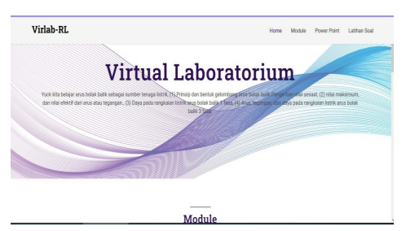 | 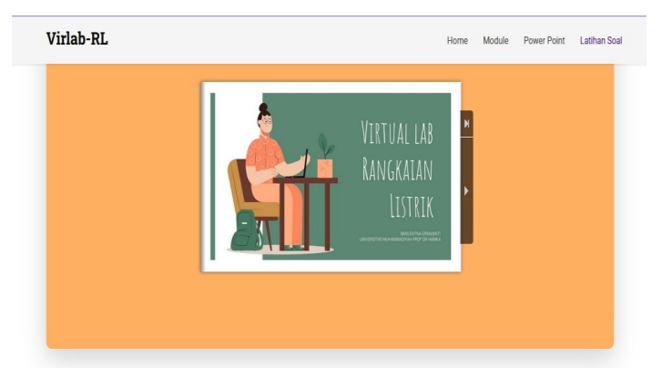
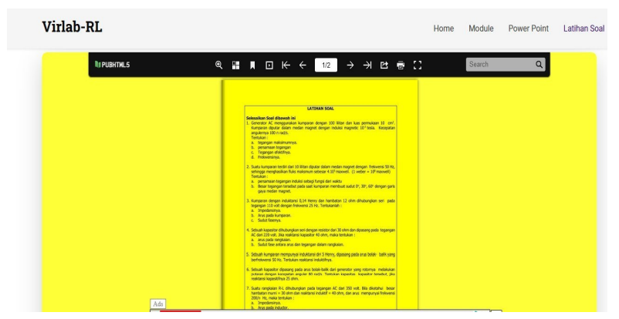 | 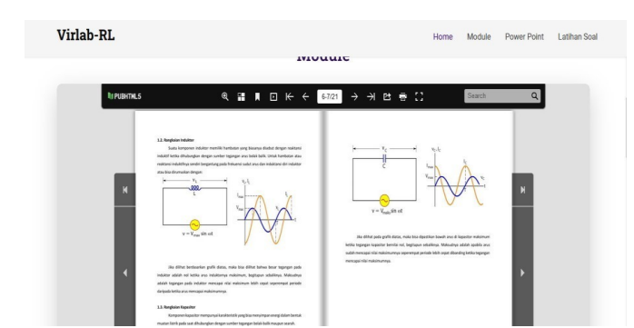
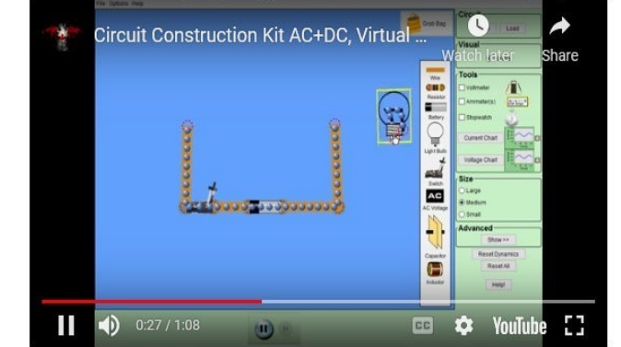 | 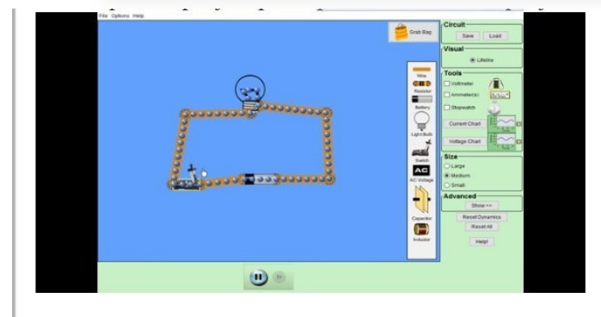
Figure 1 Content in a mobile virtual laboratory
Material Expert Validation Results. The results obtained from the first and second stage validation are in table 4.
Table 4 Results of Phase I and II Material Validation
No | Stage | Test results |  | Criteria
No | Stage | Material 1 | Material 2 | Criteria
1 | Content Eligibility | 70 | 78 | Good
2 | Serving eligibility | 62 | 76 | Good
3 | Language Eligibility | 60 | 76 | Good
4 | Contextual Assessment | 64 | 76 | Good
Average |  | 78
Criteria |  | Good
Data source: processed from the results of the material expert validation assessment instrument

The results of the first and second stages of material expert validation were 78% with the "Good" criteria. The results of the first and second stages of material expert assessment are also presented in the following graph:
Graph 1
Material Validation Results I-II
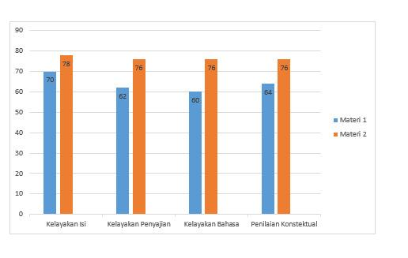
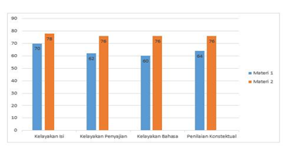
For the results of the Media Expert Validation The results obtained from the first and second stage validation are in table 5
Table 5
Result Validation Media Step I - II
No | Stage | Result Test |  | Criteria
No | Stage | Media 1 | Media 2 | Criteria
1 | Learning Design | 70 | 87 | Very Good
2 | Display Eligibility | 71 | 88,9 | Very Good
3 | Media Benefits | 62 | 85,9 | Very Good
Average |  | 87,4
Criteria |  | Very Good
Data source: processed from the results of the media expert validation assessment instrument
The results of the first and second stages of media expert validation were 87.4% with the "Very Good" criteria. The results of the first and second stages of media expert assessment are also presented in graph 2 below:
Graph 2
Media Validation Results I-II
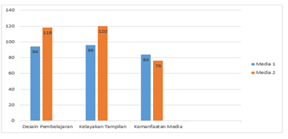

4). Preliminary Field Testing , media experts suggest to conduct an analysis using the SUMI (software usability measurement inventory) method, namely by distributing questionnaires to 5 respondents with various study program backgrounds through google form to assess aspects of efficiency, affect, helpfulness, control and learnability, can be seen in table 6
Table 6
SUMI Results of Virtual Laboratory Application
No | Nama | Categori
No | Nama | Learnability | Effect | Helpfullness | Efficiency | Control
1 | A | 50 | 60 | 55 | 80 | 65
2 | B | 55 | 65 | 60 | 75 | 60
3 | C | 60 | 65 | 65 | 80 | 65
4 | D | 65 | 70 | 60 | 80 | 60
5 | E | 50 | 75 | 60 | 80 | 60
Rata-rata |  | 58 | 67 | 60 | 81 | 62
Data source: processed from Sumi instrument results
The measure of the level of user satisfaction based on the SUMI method is taken from the average value, if it is more than the average value then it is included in the criteria of being quite satisfied or satisfied, while below the average is included in the criteria of being unsatisfied. From the results of the SUMI questionnaire conducted, of the 5 aspects assessed, 4 (four) aspects scored above the average of 60 while 1 aspect scored below the average. However, it can be said that users are quite satisfied in accessing and operating the virtual laboratory system application.
(5). Main Product Revision, from the results of trials conducted on physics education students at FKIP UHAMKA East Jakarta with a total of 10 physics education students, namely the response of participants or students in assessing the application developed by the virtual laboratory was very positive and achieved a percentage score of 80% with the criteria "Very Good ” means that the developed virtual laboratory application is feasible to use.
(6) Main Field Testing , rom the results of the field test showed that the student responses were recorded as many as 18 people from Physics Education students FKIP UHAMKA East Jakarta in assessing the application developed very positively and achieving a percentage score of 92.4% with the criteria "Very Good" meaning the virtual laboratory application of the electric circuit developed it's worth it used. The assessment of each aspect also shows the criteria of "Very Good" where aspects get a score of 95.5%, creative aspects get a score of 89.8%, efficiency aspects get 93% and interactive aspects get 92.7% while interesting aspects get a score of 90.8 %. ;(7) Operational Product Revision, in a large-scale field trial of 18 students from East Jakarta FKIP UHAMKA physics education students, it can be interpreted that the use of the Virtual Laboratory Application affects the difference in scores before and after, with an average score difference of 25, 04 because the results of the N-Gain calculation obtained t-count -11.86 and t-table 1.66 Based on the t-count criteria not being among the t-tables, then reject H0 and accept H1;
(8) Operational Field Testing (Uji Produk) , At this stage, the researcher also measured the effectiveness of the product developed towards increasing understanding through the calculation of N-Gain with the results of the pre-test and post-test scores getting an average N-Gain score of 0.92. Based on the Melzer criteria, if the average N-Gain score is N > 0.7 with 0.92 > 0.7 then it is a very high criterion. The average value of N-Gain is 0.8 which means a high level of effectiveness or feasibility of the Electrical Circuit Virtual Laboratory Application. The application developed is included in the "Very High" criteria and the N-Gain percentage score shows the number 92, meaning that the Virtual Laboratory Electrical Circuit Application developed meets the "Very Effective" criteria,
Based on pre-test and post-test assessments of physics education students at Fkip Uhamka Jakarta. Prophetic values in this case are integrated through activities in interactive virtual laboratory electric circuit media and are carried out repeatedly. Prophetic education is a process that is carried out continuously and continuously until it becomes a habit for students of prophetic integration in virtual laboratory media. Electrical circuits are inserted in sentences of invitation and instructions that are adjusted to the indicators of each value. The prophetic value can be seen in table 7.
Table 7
Prophetic Assessment
Prophetic/Character | Before | After
Shidiq /Honest | 6,52 | 8,64
Trust/Responsibility | 7,04 | 9,08
abligh/ Communicative | 8,17 | 9,33
Fathonah/Intelligent/a sense | 8,13 | 8,67
Sumber data: diolah dari hasil instrumen Profetik

Based on table 7 obtained, prophetic from prophetic questionnaires and observations are not much different, it can be concluded that prophetic before using a virtual laboratory application of electric circuits and after using it has a high level of prophetic after using a virtual laboratory application, it can also be presented in graphical 3 form below
Graphic 3
Prophetic Assessment

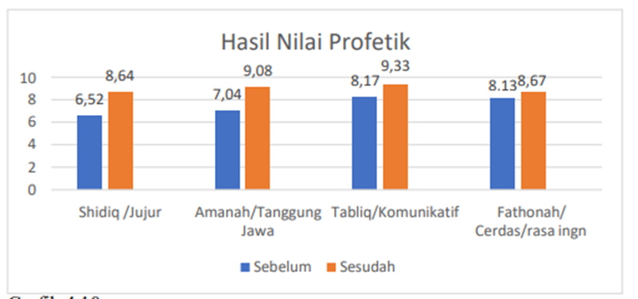

(9). Final Product Revision , rom the results of field trials 92% of physics education students stated that the "Electric Circuit Virtual Laboratory application is good" because the information presented is not monotonous and attractive by collaborating articles, pictures, videos and website links so that it is in accordance with the characteristics of current users who always use gadgets or android to explore the virtual world.
10). Dissemination and Implementation, Dissemination and Implementation of the Final Product is the stage for reporting the results in professional meetings in national and international journals and intellectual property rights to obtain legality. The output of this research is the Electric Circuit Virtual Laboratory application which can be accessed online via a link https://virlab-rl.org.

CONCLUSION
Thus it can be concluded that the Virtual Laboratory Application is feasible to use and is able to increase the competence of students / students. This is also supported by the data from the research and discussion that have been described previously, namely Virtual Laboratory application development has been validated by material experts and media experts by obtaining the criteria of "Very Good / No Need for Revision" which means that the Virtual Laboratory application is feasible to use.

REFERENCES

from a textbook:
Borg W R and Gall M D 1983 Educational Research. An Introduction (New York: Longman Inc.)
Kozma, R.B, Belle, L.W & Williams, G.W. (1978). Instructional techniques in higher education. New Jersey: Englewood Cliffts..

From a translated book
Ariani, Niken & Dany Haryanto. 2010. Multimedia learning in schools. Jakarta: Publisher Library Achievement
Sugiyono, 2013 Understanding Qualitative Research (Bandung: Alfabeta).

From Journal:
Arkun, Selay dan Buket Akkoyunlu, “A Study On The Development Process Of A Multimedia Learning Environment According To The ADDIE Model And Students’ Opinions Of The Multimedia Learning Environment,” Jurnal, Interactive Educational Multimedia, Number 17 (October, 2008), pp. 1-19, Hacettepe University, Faculty of Education, Dep. of. Comp. and Inst. Tech. Ed. Ankara, Turkey http://www.ub.edu/multimedia/iem/iemjornal@qreav.net
Zainal Arifin, Elvira Destiansari, Susy Amizera.(2020). Development of Mobile Virtual Laboratory in Practical Learning on Water Pollution Material Journal of Education, Journal of Bioedusiana 5(2), 123-130. https://doi.org/https://doi.org/10.37058/bioed.v5i2.2216
Gunawan&lilisari, 2015, Modern Physics Virtual Laboratory Model To Improve Critical Thinking Disposition for Physics Teacher Candidates. Scientific Journal of Education Horizon, LPPM UNY, June 2015, Year XXXI, no 2 .p 185-199
Nugroho, A. (2021). The effectiveness of virtual laboratories in learning Pharmacy analysis practicum for pharmacy students during the Covid-19 pandemic. Reflections on Innovative Learning, 3(1), 317-324. https://doi.org/10.20885/rpi.vol3.iss1.art1
Syifaul Fuada, Aji Widhi Wibowo (2016). Desain Dan Implementasi Virtual Laboratory Materi Osilator Analog Berbasis IC OP-AMP.Jurnal Elkomika, 4(2),134 -147. http://dx.doi.org/10.26760/elkomika.v10i4.742
Jaya, H. (2013). Development of a virtual laboratory for practicum activities and facilitating character education in SMKs. Journal of Vocational Education, 2(1), 81–90. https://doi.org/10.21831/jpv.v2i1.1019

From Thesis or Dissertation
Ahmad Robani (2018). Implementation of Deep Prophetic Education Shaping Student Character at MTS Negeri 6 Sleman, (Thesis, Yogyakarta Islamic University of Indonesia)
Firmayanti, Lilis. 2011. The Effect of Using Virtual Physics Laboratory in Different Group Sizes on Student Learning Outcomes on the Concept of Static Electricity. Thesis. Surabaya: PPs Unesa.
.
From proceeding:
Dakwah, S. F., & Semarang, U. I. N. W. (2020). Development of Virtual Laboratory as Learning Media: Opportunities and Challenges. 3(2), 77–83.
Ihsan, M. N. (2014). Development of the 2007 microsoft excel electronic module for class xi of high school. 26, 1–161. https://eprints.uny.ac.id/40035/
Wassalam, O. J. F., Umar, R., & Yudhana, A. (2017). Implementation and Development of a Web-Based E-Learning System at STMIK Muhammadiyah Paguyangan. Multi-Disciplinary National Seminar & Call of Papers, Call for Papers 3rd UNISBANK, 104–107. https://www.unisbank.ac.id/ojs/index.php/sendi_u/article/download/5002/1514/0

