DENSITY ANALYSIS OF RIVER WATER THROUGHOUT JAKARTA CITY TO HYDROSTATIC PRESSURE

¹ Denny Yatmadi, ¹Tri Wulan Sari
¹ Jurusan Teknik Sipil, Politeknik Negeri Jakarta, Indonesia
e-mail: denny.yatmadi@sipil.pnj.ac.id, tri.wulansari@sipil.pnj.ac.id

Abstract
Different activities of a river area, can caused differences in density and hydrostatic pressure of the fluid contained in rivers in different places. This study aims to analyze the relationship between density and hydrostatic pressure fluid of 5 rivers that cross Jakarta and empties into Jakarta Bay. Laboratory testing is carried out using the Center of Pressure tool. The data obtained after the test are mass, weight, moment, and Perspex water level. The data were analyzed using the appropriate formula to obtain the density of water from 5 research locations. Then continued the analysis of the hydrostatic pressure at the research site. The results obtained indicate that the hydrostatic pressure is directly proportional to the density of the liquid. Like the hydrostatic pressure in Sunter drain, the highest hydrostatic pressure among the others is 10389.24 N/m², with the highest density of water also being 1060.13 kg/m³.
Keywords : River; fluid; center of pressure ; Density; Hydrostatics pressure.

ANALISIS MASSA JENIS AIR SUNGAI yang MELINTASI KOTA JAKARTA terhadap TEKANAN HIDROSTATIS

Abstrak
Aktivitas yang berbeda dari suatu kawasan sungai, menyebabkan adanya perbedaan massa jenis dan tekanan hidrostatis fluida yang terdapat pada sungai di tempat yang berbeda. Penelitian bertujuan untuk menganalisis hubungan antara massa jenis dengan tekanan hidrostatis fluida 5 Sungai yang melintasi Jakarta dan bermuara di Teluk Jakarta. Pengujian laboratorium dilakukan dengan menggunakan alat Center of Pressure. Data yang didapat setelah pengujian adalah massa, berat, momen, dan ketinggian muka air Perspex. Data tersebut dianalisis dengan menggunakan rumus yang sesuai sehingga diperoleh massa jenis air dari 5 lokasi penelitian. Kemudian dilanjutkan analisis terhadap tekanan hidrostatis pada lokasi penelitian. Hasil yang diperoleh menunjukkan bahwa tekanan hidrostatis berbanding lurus dengan besarnya massa jenis zat cair. Seperti halnya tekanan hidrostatis di Sunter drain paling tinggi diantara tekanan hidrostatis yang lain yaitu sebesar 10389,24 N/m³, dengan massa jenis air tertinggi pula yaitu sebesar 1060,13 kg/m³.
Kata Kunci: Sungai; Zat Cair; Center of Pressure ; Massa Jenis; Tekanan Hidrostatik.

INTRODUCTION
Maintenance of rivers basically aims to maintain the water capacity and the holding capacity of all river water systems in the drainage area such as rivers, estuary, drainage canals and all water structures contained in the system. The rivers can be interpreted as a container for gathering water from an area. Surface water or runoff water flows by gravity from a high place to a lower place (Yogafanny, 2015). The cross section of the river has a balance between the flow and the characteristics of the sediment carried by the flow. Equilibrium is achieved when the driving and resisting forces are in balance. Human activities around the river greatly affect the quality of the river water (Yogafanny, 2015).
Different activities of a river area cause differences in density and hydrostatic pressure of the fluid contained in rivers in different places. Density can be defined as a property of a material, so another meaning is mass divided by unit volume, which can be formulated 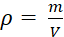 (Zemansky's & Freedman, 2012). Different densities can be caused by the material inhabiting the liquid is also different. The density of river water is 1000 kg/m3 (Kasli & Aminullah, 2016). When a fluid is at rest, it exerts a force perpendicular to any surface in contact with it, such as a container wall or a body immersed in the fluid. This is the force that you feel pressing on your legs when you dangle them in a river. While the fluid as a whole is at rest, the molecules that make up the fluid are in motion; the force exerted by the fluid is due to molecules colliding with their surroundings (Zemansky's & Freedman, 2012). Researcher defines the pressure P at that point as the normal force F per unit area A, with the formula 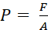. River water measured in this study is considered a static fluid, a quantity that is closely related to this static fluid is hydrostatic pressure. Hydrostatic pressure is the pressure that occurs in a liquid at rest. The hydrostatic pressure that occurs at a place depends on the density of the liquid and the depth of the object. If the depth of the object is considered the same, then the main parameter that causes the high and low of the liquid is the density of water.
From the description above, the researcher can take the aim of the study is to analyze the relationship between density and hydrostatic fluid pressure 5 Rivers that cross Jakarta and disembogue into Jakarta Bay.

METHODS
The research methods used are quantitative methods, field surveys and laboratory testing. Quantitative research methods are methods that are carried out based on the data obtained in the form of numbers (Syahrum & Salim, 2012). The survey and sampling was carried out on 30 – 31 July 2021, located in 5 rivers in Jakarta, namely the West Flood Canal, Ciliwung Lama estuary, East Flood Canal, Sunter, and Cakung. Figure 1 below is the location of the study area as a whole.
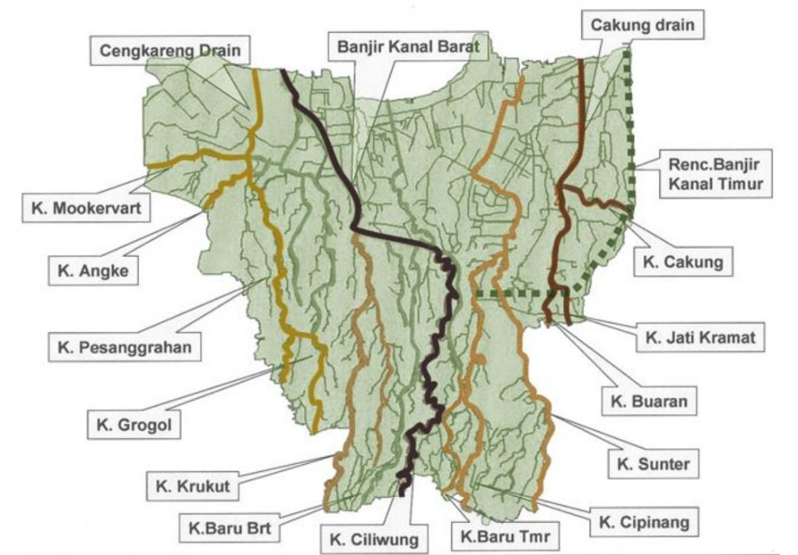
Figure 1 : Research Location in Jakarta

The primary data obtained during the research are mass data, perspective length, and height indicated by the tool. Secondary data moment, weight, specific gravity. Figure 2 below shows a flow chart of the research conducted by the author. Starting from a site survey, then sampling in 5 rivers of Jakarta. After the data was obtained, an experiment was carried out using the Center of Pressure. Next calculate the density of water and hydrostatic pressure. The last step is to analyze the data based on the results of the calculations that have been done.
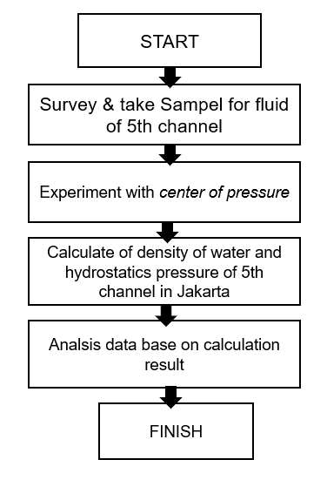
Figure 2 : Research flowchart

RESULT AND DISCUSS

Survey and take sampel of river water
The survey and sampling were carried out for two days, starting on July 30 – July 31, 2021. It was carried out at 5 river points in Jakarta, namely the West Flood Canal, Ciliwung Lama estuary, East Flood Canal, Sunter, and Cakung. The following are rivers and samples taken by researchers. The five locations are rivers that cross Jakarta and disembogue into Jakarta Bay.
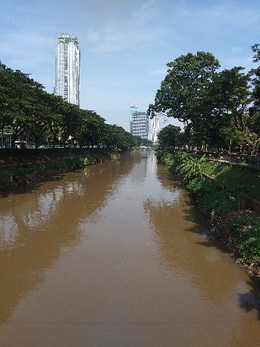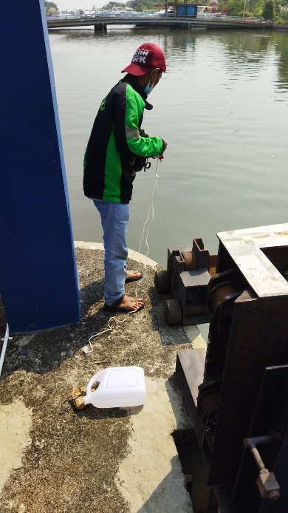
Figure 3 : River of Kanal Banjjir Barat and old Ciliwung estuary

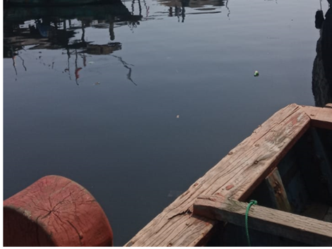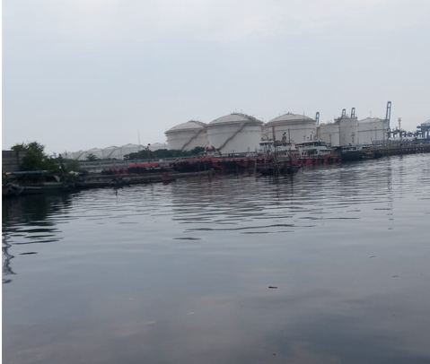
Figure 4 : Cakung Drain and Sunter Drain

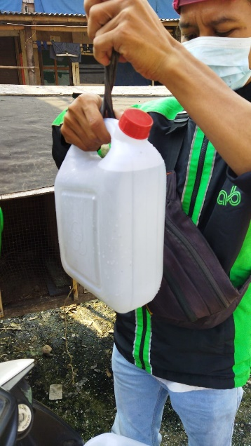
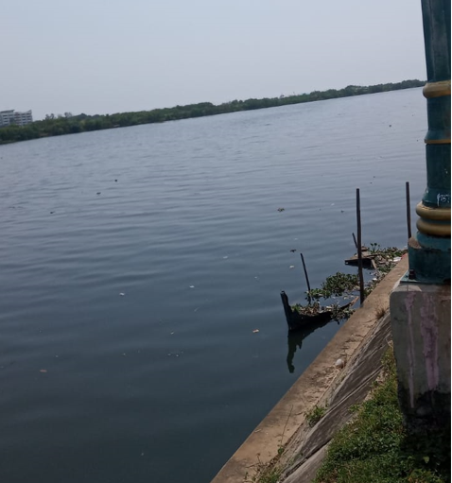
Figure 5 : Kanal Banjir Timur and take a sampel

Density
One of the quantities that must be calculated to determine the depositional pattern of cohesive sediments is density. After obtaining river water sample data in the previous step, the researchers conducted laboratory tests carried out at the PNJ Civil Engineering Hydraulics Laboratory. The calculation formula is carried out, if the result of the height shown by the tool is less than R1 which is 100 mm, then the calculation formula used is equation 1. If it is more than R1 then the calculation formula uses the second equation. The tool used by the examiner is the Center of Pressure. The specifications of the tools used are:
a. moment arm length 250 mm
b. Perspex curved spokes R1 = 100 mm; R2 = 250 mm
c. Perspex Width 75 mm
d. Tests were carried out using loads of 50, 100, 150, 200, 250, 300 grams.
e. The reference Density is 980 - 1000 kg/m3 (Kasli & Aminullah, 2016)
f. The formula used is as follows

………… equation 1
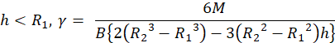
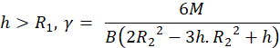

… equation 2

Figure 6 are set instrument of Center of Pressure in Laboratorium Hidrolika Teknik Sipil PNJ to get specific gravity from river water of 5 location.
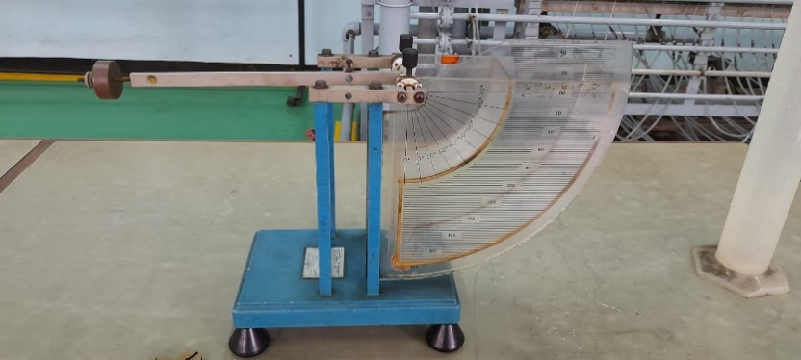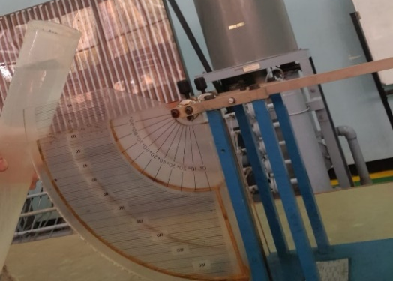
Figure 6 : Center of pressure in Laboratorium Hidrolika Teknik Sipil PNJ
Table 1 is a test carried out at the Kanal Banjir Barat Location carried out on August 9, 2021, with seawater liquid using room temperature. The result is that the density obtained is 10.49 kN/m3, so that if it is used as a density, it is 1048.77 kg/m3. This result exceeds the density of the reference water, which is 980 - 1000 kg/m3.

Table 1. Result of test doing in Kanal Banjir Barat location
No | Massa |  | Berat | Momen | h |  | γ |  | Keterangan
No | (gr) | (kg) | W = m.g (N) | M = W . L (N.m) | (mm) | (m) | (N/m^3) | (kN/m^3) | Keterangan
1 | 50 | 0,05 | 0,5 | 0,125 | 160 | 0,16 | 11160,71 | 11,16 | h > R1
2 | 100 | 0,1 | 1 | 0,25 | 140 | 0,14 | 10288,07 | 10,29 | h > R1
3 | 150 | 0,15 | 1,5 | 0,375 | 126 | 0,126 | 10415,31 | 10,42 | h > R1
4 | 200 | 0,2 | 2 | 0,5 | 114 | 0,114 | 10522,04 | 10,52 | h > R1
5 | 250 | 0,25 | 2,5 | 0,625 | 102 | 0,102 | 10370,84 | 10,37 | h > R1
6 | 300 | 0,3 | 3 | 0,75 | 90 | 0,09 | 10169,49 | 10,17 | h < R1
γ rata-rata = |  |  |  |  |  |  |  | 10,49

Table 2 is a test result carried out at the old Ciliwung location with liquid water using room temperature. The result is that the density obtained is 10.53 kN/m3, so that if it is converted into density it is 1052.9 kg/m3. This result also exceeds the reference density.
Table 2. Result of test doing in Ciliwung Lama location
No | Massa |  | Berat | Momen | h |  | γ |  | Keterangan
No | (gr) | (kg) | W = m.g (N) | M = W . L (N.m) | (mm) | (m) | (N/m^3) | (kN/m^3) | Keterangan
1 | 50 | 0,05 | 0,5 | 0,125 | 160 | 0,16 | 11160,71 | 11,16 | h > R1
2 | 100 | 0,1 | 1 | 0,25 | 142 | 0,142 | 10969,19 | 10,97 | h > R1
3 | 150 | 0,15 | 1,5 | 0,375 | 126 | 0,126 | 10415,31 | 10,42 | h > R1
4 | 200 | 0,2 | 2 | 0,5 | 112 | 0,112 | 10088,46 | 10,09 | h > R1
5 | 250 | 0,25 | 2,5 | 0,625 | 102 | 0,102 | 10370,84 | 10,37 | h > R1
6 | 300 | 0,3 | 3 | 0,75 | 90 | 0,09 | 10169,49 | 10,17 | h < R1
γ rata-rata = |  |  |  |  |  |  |  | 10,53

Table 3 is a test carried out at the Sunter Drain Location with liquid river water using room temperature. The result is that the density obtained is 10.38 kN/m3, so that if it is converted to density it is 1038 kg/m3. The result exceeds the reference density.

Table 3. Result of test doing in Sunter Drain location
No | Massa |  | Berat | Momen | h |  | γ |  | Keterangan
No | (gr) | (kg) | W = m.g (N) | M = W . L (N.m) | (mm) | (m) | (N/m^3) | (kN/m^3) | Keterangan
1 | 50 | 0,05 | 0,5 | 0,125 | 160 | 0,16 | 11160,71 | 11,16 | h > R1
2 | 100 | 0,1 | 1 | 0,25 | 138 | 0,138 | 9670,84 | 9,67 | h > R1
3 | 150 | 0,15 | 1,5 | 0,375 | 126 | 0,126 | 10415,31 | 10,42 | h > R1
4 | 200 | 0,2 | 2 | 0,5 | 114 | 0,114 | 10522,04 | 10,52 | h > R1
5 | 250 | 0,25 | 2,5 | 0,625 | 102 | 0,102 | 10370,84 | 10,37 | h > R1
6 | 300 | 0,3 | 3 | 0,75 | 90 | 0,09 | 10169,49 | 10,17 | h < R1
γ rata-rata = |  |  |  |  |  |  |  | 10,38

Table 4 is a test carried out at the Cakung Location with river water liquid using room temperature. The result is that the density obtained is 10.60 kN/m3, so that if it is converted to density it is 1060 kg/m3. The result exceeds the reference density.
Table 4. Result of test doing in Cakung drain location
No | Massa |  | Berat | Momen | h |  | γ |  | Keterangan
No | (gr) | (kg) | W = m.g (N) | M = W . L (N.m) | (mm) | (m) | (N/m^3) | (kN/m^3) | Keterangan
1 | 50 | 0,05 | 0,5 | 0,125 | 160 | 0,16 | 11160,71 | 11,16 | h > R1
2 | 100 | 0,1 | 1 | 0,25 | 142 | 0,142 | 10969,19 | 10,97 | h > R1
3 | 150 | 0,15 | 1,5 | 0,375 | 126 | 0,126 | 10415,31 | 10,42 | h > R1
4 | 200 | 0,2 | 2 | 0,5 | 114 | 0,114 | 10522,04 | 10,52 | h > R1
5 | 250 | 0,25 | 2,5 | 0,625 | 102 | 0,102 | 10370,84 | 10,37 | h > R1
6 | 300 | 0,3 | 3 | 0,75 | 90 | 0,09 | 10169,49 | 10,17 | h < R1
γ rata-rata = |  |  |  |  |  |  |  | 10,60

Table 5 is a test carried out at the East Flood Canal Location with river water liquid using room temperature. The result is that the density obtained is 10.32 kN/m3, so that when converted into a density, it is 1032 kg/m3. The result exceeds the required reference density.

Table 5. Result of test doing in Kanal Banjir Timur location
No | Massa |  | Berat | Momen | h |  | γ |  | Keterangan
No | (gr) | (kg) | W = m.g (N) | M = W . L (N.m) | (mm) | (m) | (N/m^3) | (kN/m^3) | Keterangan
1 | 50 | 0,05 | 0,5 | 0,125 | 160 | 0,16 | 11160,71 | 11,16 | h > R1
2 | 100 | 0,1 | 1 | 0,25 | 138 | 0,138 | 9670,84 | 9,67 | h > R1
3 | 150 | 0,15 | 1,5 | 0,375 | 126 | 0,126 | 10415,31 | 10,42 | h > R1
4 | 200 | 0,2 | 2 | 0,5 | 114 | 0,114 | 10522,04 | 10,52 | h > R1
5 | 250 | 0,25 | 2,5 | 0,625 | 100 | 0,1 | 10000,00 | 10,00 | h > R1
6 | 300 | 0,3 | 3 | 0,75 | 90 | 0,09 | 10169,49 | 10,17 | h < R1
γ rata-rata = |  |  |  |  |  |  |  | 10,32

Of the 5 densities that were tested with river water samples taken in different places, there were different results from the reference results of the density of water. The results of the 5 densities of the 5 different rivers are presented in table 6 below. It can be seen that Sunter drain has the highest density among the others, followed by the old Ciliwung Muara, then the West Flood Canal, and Cakung Drain, and the East Flood Canal.
Table 6 : The results of the calculation of the density of 5 research locations
No. | Location | Density () kg/m^3
1 | Kanal Banjir Barat | 1048,77
2 | Muara Ciliwung Lama | 1052,90
3 | Cakung Drain | 1038,49
4 | Sunter Drain | 1060,13
5 | Kanal Banjir Timur | 1032,31
To find out the hydrostatic pressure in these 5 locations, we need to do calculations to conclude which location is the greatest hydrostatic pressure. Here are the 5 types of density when displayed in a pie chart. It can be seen that all slices have almost the same value.
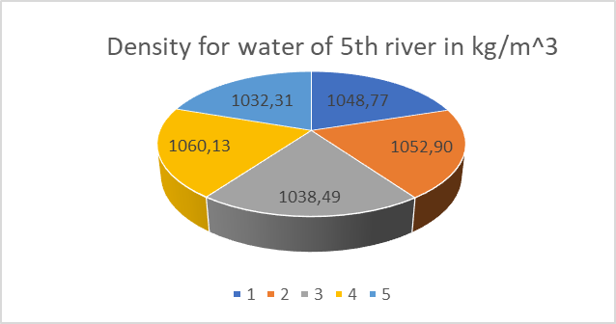
Figure 7. Diagram pie water density of 5th river in kg/m³

Hydrostatics Pressure
A fluid that does not undergo displacement in its parts is called a static fluid. There are several interrelated concepts in static (hydrostatic) fluids, including; hydrostatic pressure, viscosity of liquids (viscosity), Pascal's law, Archimedes' law, capillarity, and surface tension (Kasli & Aminullah, 2016). Hydrostatic pressure is the pressure that comes from the force that exists in the liquid to the pressure field area with a certain depth ( Serway & Jewett, 2018) (Knight, 2017) (Zulfa, Nikmah, & Nisa, 2020). Based on the concept of hydrostatic pressure occurs according to Pascal's law. An important concept in hydrostatic pressure is that the density of the container does not affect the hydrostatic pressure of the fluid, but is influenced by the density of the liquid, the surrounding air, the acceleration of gravity of the earth and the depth of the object in the liquid. An important concept that needs to be understood is also the principles of Pascal's law (Zulfa, Nikmah, & Nisa, 2020) ( Serway & Jewett, 2018).
In this study, the researcher compares the depth of the object to the same (h) which is within a radius of 1 meer from the surface of the water, the acceleration of gravity of the earth is 9.8 m/s2 so that the hydrostatic pressure calculation that the author does uses the equation . Table 7 The following is the result of the calculation of hydrostatic pressure at the 5 tested locations.
Table 7 : The results calculation of the hydrostatics pressure of 5 research locations
No. | location | density () kg/m^3 | hydrostatics pressure (N/m^2)
1 | Kanal Banjir Barat | 1048,77 | 10277,99
2 | Muara Ciliwung Lama | 1052,90 | 10318,42
3 | Cakung Drain | 1038,49 | 10177,18
4 | Sunter Drain | 1060,13 | 10389,24
5 | Kanal Banjir Timur | 1032,31 | 10116,60

The author also made the hydrostatic pressure in the pie chart, it can be seen that the Sunter drain has the highest hisrostatic pressure among the others, which is 10389.24 N/m² , with a water density of 1060.13 kg/m³ , followed by the Old Ciliwung Estuary, then the Kanal Banjir Barat, and Cakung Drain, and the lowest hydrostatic pressure is in the East Flood Canal with a hydrostatic pressure of 10116.60 N/m².

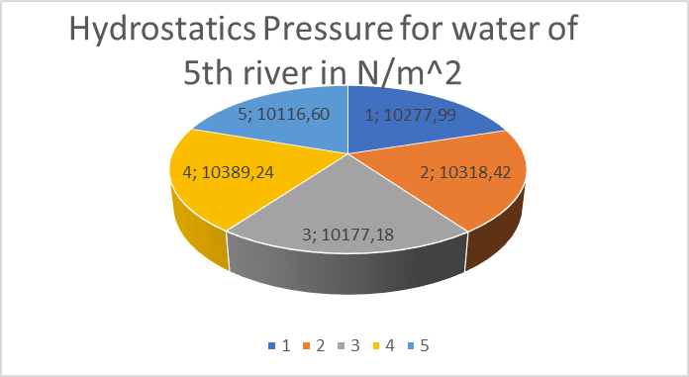
Figure 7. Diagram pie hydrostatics pressure of 5th river in N/m²
Figure 8 below is a graph of the relationship between density and hydrostatic pressure that occurs in 5 research locations. In the graph it is clear that the hydrostatic pressure is directly proportional to the density of the liquid. The highest density in Sunter drain with number 4 is 1060.13 kg/m³ , has the highest hydrostatic pressure, which is 10389.24 N/m² . Then followed by the density of the Ciliwung Lama estuary of 1052.90 kg/m³, obtained a hydrostatic pressure of 10318.42 N/m². Furthermore, the third order is at number 1, namely at the location of the West Flood Canal with a density of 1048.77 kg/m³ and a hydrostatic pressure of 10277.99 N/m². The fourth order in symbol number 3 with a density of 1038.49 kg/m3 is at the Cakung drain location with a hydrostatic pressure of 10177.18 N/m². And in the last order the density is 1032.31 kg/m³, with a hydrostatic pressure of 10116.60 N/m²in the Kanal Banjir Timur. The difference in the density of water that occurs at the research site is probably due to the material contained in the liquid, for example garbage, waste, and so on.
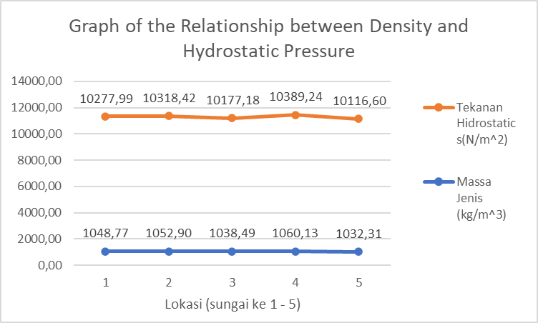
Figure 8 : Graph of the Relationship between specific gravity and Hydrostatic Pressure

CONCLUSSION
Based on the results and discussion, it is concluded that the hydrostatic pressure is directly proportional to the density of the liquid. A liquid has a greater density than others, it is certain that the liquid has a large hydrostatic pressure. As with the hydrostatic pressure in Sunter drain, the highest among other hydrostatic pressures is 10389.24 N/m², with the highest density of water also being 1060.13 kg/m³.

REFERENCES
Serway, R. A., & Jewett, J. W. (2018). Physics for scientists and engineers with modern physics. Cengage learning.

Kasli, E., & Aminullah. (2016). Pengaruh Massa Jenis Benda Terhadap Tekanan Hidrostatis . Jurnal Pendidikan Geosfer , 16-19.

Knight, R. D. (2017). Physics for scientists and engineers. Pearson Higher Ed.

Syahrum, & Salim. (2012). Metodologi Penelitian Kuantitatif. Bandung: Citapustaka Media.

Yogafanny, E. (2015). Pengaruh Aktifitas Warga di Sempadan Sungai terhadap Kualitas Air Sungai Winongo. Jurnal Sains dan Teknologi Lingkungan , 41-50.

Zemansky's, S., & Freedman, Y. (2012). University Physics with Modern Physics 13th Edition. Pearson.

Zulfa, S. I., Nikmah, A., & Nisa, E. K. (2020). Analisis Penguasaan Konsep pada Tekanan Hidrostatis dan Hukum Pascal Mahasiswa Pendidikan Fisika. Yogyakarta: UGM.

